he Official Publication of ALOA—An International Association of Security Professionals

wiAiw.aloa.org

ebruary 2002

dlock

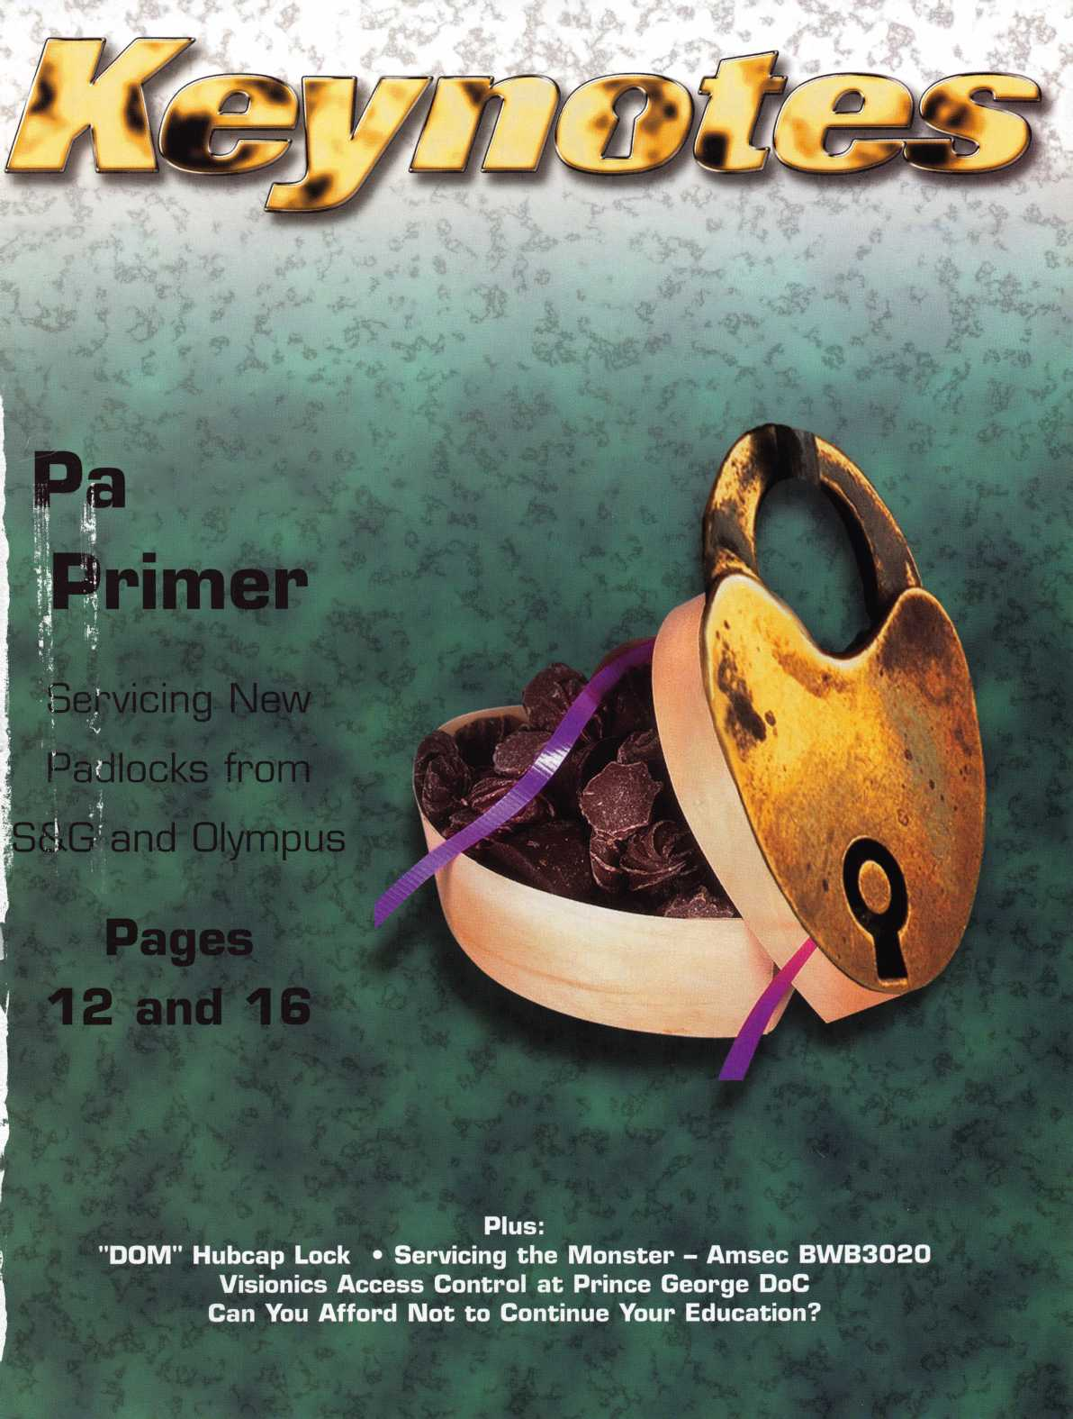

Pick Up Some Players

Attention Current Members! As the best security pros in  
the world, you play a vital role in making ALOA what it  
is. You make our industry hum, and we're going to  
prove it this year by offering you more benefits than  
ever. For the entire calendar year of 2002, those who  
recruit new members will receive special gifts from  
ALOA. We're asking you to prove you're a pro by sup-  
porting the only professional organization that exists to  
help educate, protect and promote security profession-  
als in America and beyond. Here are some of the  
details of our campaign:

**For Chapters and Affiliates Who Recruit!**

If your chapter gets 15 new members: ALOA will send instructors out to your site for two free days of ACE classes FREE OF CHARGE! Plus, the chap­ter or affiliate that recruits the most new members gets three free convention packages for our blowout show in sparkling Las Vegas in July of 2003!

Don't pass up this fantas­tic chance for these gr|at free giveaways, an ~ expanded group of peers with whom to learn and

AIUA locksmiths Secure America

**For New Members!**

All newly recruited members receive a useful ALOA  
11-piece pick set from LAB, plus our stirring "ALOA  
Locksmiths Secure America" decal for the shop or van

**For Current Members Who Recruit!**

1 new member: The useful ALOA 11-piece pick set  
from LAB.

5 new members: A handsome ALOA Polo Shirt (w/ grow, and the same

stitched logo) fantastic education,

10 new members: LAB's great Schlage/Kwikset protection and promotion

Combination pin kit -- plus membership in the ALOA ALOA has been providing

President's Club, with your choice of a dazzling ALOA f°r our great profession

ring or a classic ALOA blazer (plus a periodic listing f°r almost 50 years! Call  
in Keynotes). us today at 800/532-ALOA

(2562) for more informa-

i

i

!

tion, or visit us on the  
web at [www.aloa.org](http://www.aloa.org).

Hew /ty

**ALOA Membership. Prove You're a Pro**

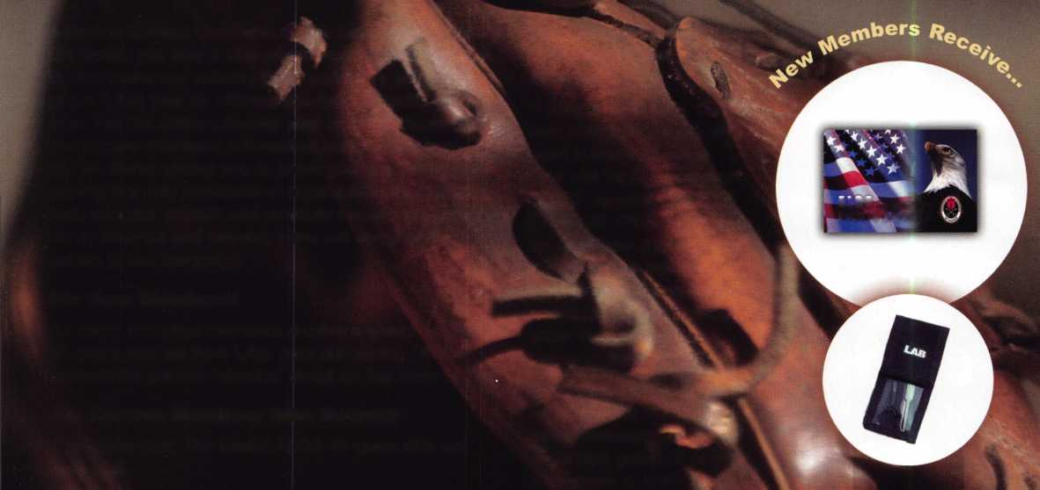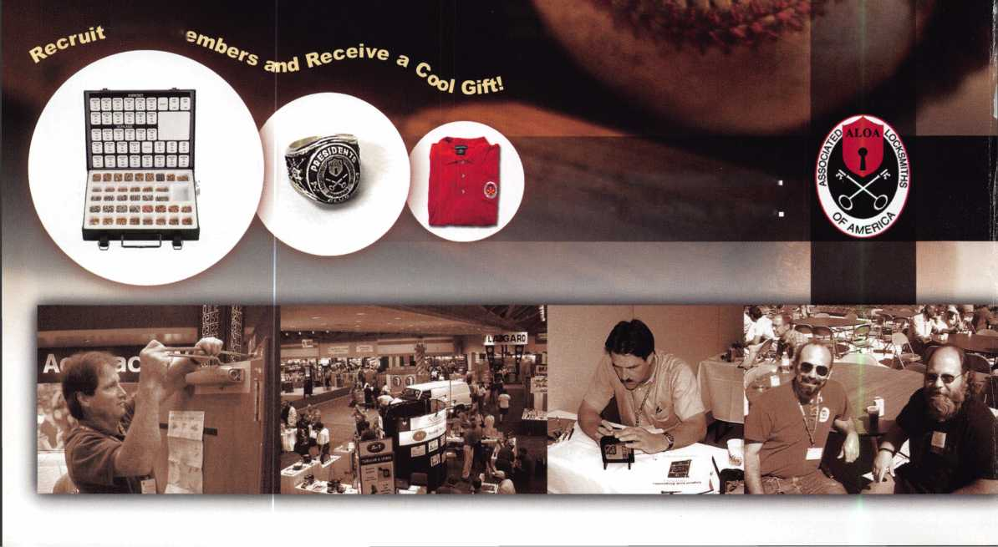

**features**



COVER

The S&G 8077 Padlock...Undressed

By Greg Perry, CML, CPS

The 8077 can be a tricky padlock to service - if you don't know  
how to take away its armor first.

**16**

COVER

Olympus Padlocks By Sal Dulcamaro, CML

Take a look inside this new lock with variations on some tradition­al padlock features.

|  |  |
| --- | --- |
| d | epartments |
| 4 | President's Journey |
| 6 | Upcoming Events |
| 8 | Applicants |
| 10 | Core |
| 10 | Legislative Update |
| 40 | Classifieds |
| 42 | Associate Member Listing |
| 44 | Back Page |
| L | J |

**20**

Time for a Rehanging

By Greg Perry, CML, CPS

**24**

SAFES

Getting through to a Monster— Servicing the Amsec BWB3020

By Milton Wolferseder

**27**

AUTOMOTIVE

"DOM" Hubcap Lock By Red Howell, CRL, ACE Instructor

The most expensive cars on the market have special servicing needs. Here's how to keep the caps on a Rolls Royce.

**30**

ACCESS CONTROL

Visionics Access Control at Prince George DoC

**34**

OPINION

Licensing is What the Future Needs

By Karl Kretsch

V i

our we

b s i t e at

WWW

. a I

oa.org

Keynotes • February 2002

■'A ,*

m mm -- ^

ft v'-i-y;

July 22-28, 2002 • Donald E. Stephens Convention Center • Hyatt Regency O'Hare

ALfr!A

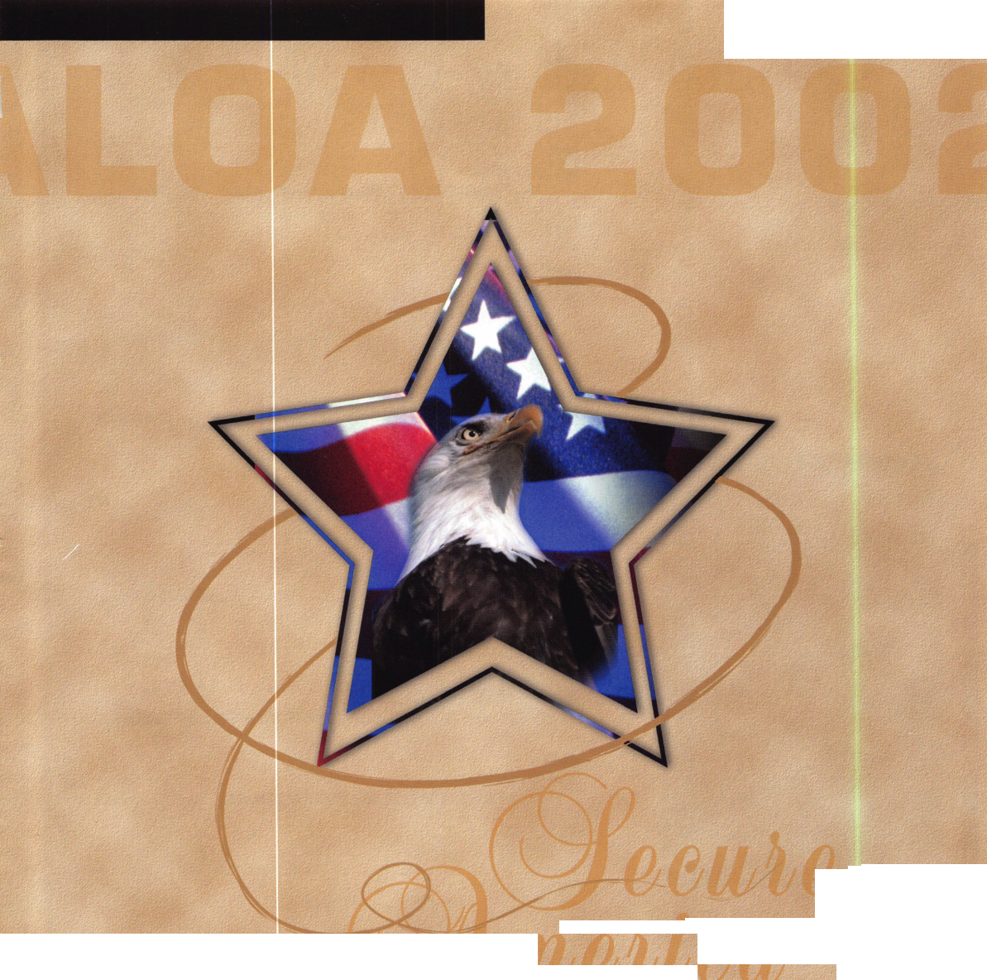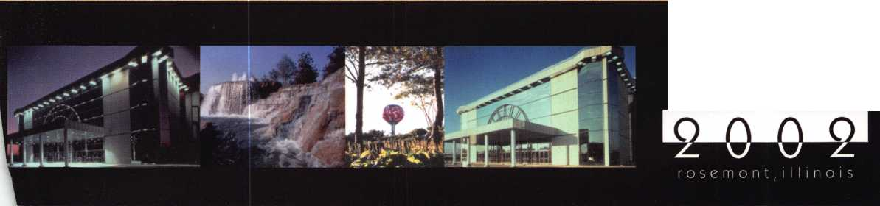

executive



Additional contact information for the ALOA Board and most Keynotes authors is  
available through "Locksmith Search'" on the ALOA Web site- [www.aloa.org](http://www.aloa.org) or by  
contacting the ALOA office at 3003 Live Oak Street; Dallas, TX 75204; (800)532-2562;  
FAX (214)827-1810; e-mail [aloa@aloa.org](mailto:aloa@aloa.org).

|  |  |  |  |
| --- | --- | --- | --- |
| Editor |  | Operations/Membership Manager | |
| Jim DeSimone | [editor@aloa.org](mailto:editor@aloa.org) | Mary May | [mary@aloa.org](mailto:mary@aloa.org) |
| Technical Editor |  | Director of Information Technology | |
| David Lowell, CML, CMST .... | [david@aloa.org](mailto:david@aloa.org) | Randy McChristian | [randy@aloa.org](mailto:randy@aloa.org) |
| Editorial Advisor |  | Government Affairs Manager/ | |
| John D. Cannon, CML | [jdcannon@worldnet.att.net](mailto:jdcannon@worldnet.att.net) | Chapters & Regional Associations Liaison | |
|  |  | Tim McMullen | [tim@aloa.org](mailto:tim@aloa.org) |
| Art Director |  |  |  |
| Betty Henderson | [betty@aloa.org](mailto:betty@aloa.org) | Comptroller | Kathy J. Romo |
| Advertising Sales | ... e-mail: [adsales@aloa.org](mailto:adsales@aloa.org) | Network Specialist | Greg Jackson |
| Executive Director |  | Membership Coordinator | Shelly Jett |
| Charles W. Gibson, Jr., CAE | [charlie@aloa.org](mailto:charlie@aloa.org) |  |  |
|  |  | Convention & Meetings Assistant | |
| Convention & Meetings Manager | | Karen Lyons | [karen@aloa.org](mailto:karen@aloa.org) |
| Kelly Carr, CMP | [kelly@aloa.org](mailto:kelly@aloa.org) | PRP/Education Coordinator | Ashley Manson |
| PRP/Education Manager |  |  |  |
| David Lowell, CML, CMST .... | [david@aloa.org](mailto:david@aloa.org) | Accounting Coordinator | Kathy Stokes |
|  |  | Mail Room Coordinator | Dennis Henderson |
| Contributors |  |  |  |
| Jerome Andrews, CML | Sal Dulcamaro, CML | Mike Oehlert, CPL, CPS | Tom Seroogy |
| Paul Chandler, CRL | Billy Edwards, CML | Randy Simpson, CML | Charles Stephenson, CPS |
| Claire Cohen, CML | Dan Graffeo, CRL,CMST | Robert Stafford, CML | Dennis Watanabe, CML, |
| Brian Costley, CML, CMST | A.J. Hoffman, CML | Dave Thielen, CML | CMST |
| Ray D'Adamo, CML | Jeff Nunberg, CML, CMST | Greg Perry, CML,CPS |  |

Mission Statement: The Associated Locksmiths of America, Inc. is dedicated to enhancing the professionalism, education and ethics among locksmiths and those in related sectors of the physical security industry. With approximately 10,000 members in the United States, Canada and the freeworld, ALOA is poised to help members obtain the knowledge, the strength, and the confidence to perform their role in the physical security field with pride and dignity. But it is only through active involvement and participation that ALOA can fully achieve its potential—and can help members to achieve theirs.

Policies: Keynotes® is the official publication of the Associated Locksmiths of America, Inc. (ALOA). Keynotes® acts as a moderator without approving, disapproving, or guaranteeing the validity or accuracy of any data, claim, or opinion appearing under a byline or obtained or quoted from an acknowl­edged source. The opinions expressed by the authors do not necessarily reflect the official views of ALOA. Also, appearance of advertisements and new products or service information does not constitute an endorsement of products or services featured by the Association. The Association does not accept responsibility for the inaccuracy of any data, claim, or opinion appearing in this publication, due to typographical errors on the part of the authors, Association staff or its agents.

Editor's Note: This publication is designed to provide accurate and authoritative information in regard to the subject matter covered. It is provided and disseminated with the understanding that the publisher is not engaged in rendering legal or other professional services. If legal advice and other expert assistance is required, the services of a competent professional should be sought.

Authors' Payment: Payment for eligible submissions to Keynotes will be based on the following criteria: topic, time spent and past contributions. Authors who regularly submit to Keynotes® are generally paid a higher rate. The latter is especially true of authors who write to fit specific editorial needs and submit said copy by Keynotes® deadlines. As a general guideline: Average payment for a 750 word, business or 'light' technical article would be $200. Payment for a 1500 word article involving significantly higher time and research efforts would be $400.

Payment will not be offered for articles submitted by ALOA employees or members of the ALOA Board of Directors (unless material is of a technical nature), nor for articles submitted by a company that promote that company's products or services. ALOA reserves the right not to pay for articles sub­mitted by an individual(s) that promote a particular company's products or services.

Disclaimer: The Associated Locksmiths of America, Inc., (ALOA), reserves the right to refuse any article for any reason. Additionally, ALOA reserves the right to edit, amend or modify any article submitted for publication in order to preserve technical accuracy, clarity, fairness or grammatical cor­rectness. ALOA will make the best efforts to notify the author of any changes. The extent of ALOA's liability for any article or information contained therein will be a notice of correction or retraction in the next possible issue.

Keynotes® (ISSN 0277 0792) is published monthly except for the combined June/July issue by The Associated Locksmiths of America, Inc., 3003 Live Oak St., Dallas, TX 75204-6186. Telephone: (214) 827-1701; FAX (214) 827-1810; e-mail [aloa@aloa.org](mailto:aloa@aloa.org). Subscription rates for members—$15.00 per year. Second class postage paid at Dallas, Texas. POSTMASTER: Send address changes to: Keynotes, 3003 Live Oak St., Dallas, TX 75204-6186. © Copyright 1999, All rights reserved. No part of the contents may be reproduced or reprinted in any form without prior written permission of the publisher.

President

Randy Simpson, CML  
(713)780-7026  
[president@aloa.org](mailto:president@aloa.org)

Secretary

John D. Cannon, CML  
(703)960-6413  
[jdcannon@worldnet.att](mailto:jdcannon@worldnet.att). net

Directors, Northeast

John C. Magee, lil  
(856) 845-3434

Peter Sarailian, CRL  
(201) 947-6291  
[psarailian@yahoo.com](mailto:psarailian@yahoo.com)

William L. Young, CML  
(610) 647-5042

Directors, Southeast

Vincent Formon, CML, CPS  
(901) 324-2910

Donald E. Rub, CML  
(601) 324-2658  
ruiecml@ebicom. net

Directors, North Central

Mark E. Blum, CML, CPS  
(517) 482-5809  
[mblum@arq.net](mailto:mblum@arq.net)

John Soderiand, CML, CMST  
(414) 327-5625  
ncd i rector@a loa. org

Director, South Central

Randy L. Simpson, CML

1. 780-7026

Directors, Southwest

Gordon R. Racine, CML  
(719) 384-4707  
swdirector@aba .org

Julie McCluney, CRL

1. 636-5652 swdirecfor@aloo. O'g

Director, Northwest

Scott L. Henke, CRL, CPS  
(907) 248-3785  
[action@alaska.net](mailto:action@alaska.net)

Director, Associate Members

David F. Matthies  
(727) 541-5536  
[dmatthies@southernbck.com](mailto:dmatthies@southernbck.com)

Trustees

John j. Greenan, CML. CPS  
(773) 486.2030

Dallas Brooks  
(334) 826-8990

David M. Lowell, CML, CMST  
(800) 532-2562  
Edwin Toepfer, RL  
(416)225-5589

Past Presidents

1999-2001 John Greenan, CML, CPS  
1997-1999 Dallas C. Brooks  
1995-1997 David Lowell, CML, CMST  
1993-1995 Breck Camp, CML  
1991-1993 Henry Printz, CML  
1989-1991 Evelyn Wersonick, CML, CPS  
1987-1989 Leonard Passarelfo, CPL  
1985-1987 Joe Jackman, CML  
198 3-1985 Stanley Haney, CPL  
1981-1983 Louis LaGreco, CPL  
1979-1981 John Kerr, RL  
1977-1979 Clifford Cox, CML  
1974-1977 Charles Hetherington  
1972-1974 Gene taughridge  
1970-1972 William Dutcher, RL  
1968-1970 Constant Maffey, RL  
1966-1968 Harold Edeisfein, RL  
1964-1966 William Meacham  
1962-1964 Robert Rackiiffe, CPL  
1960-1962 Edwin Toepfer, RL  
1956-1960 Ernest Johannesen

Keynotes • February 2002



Hello Members,

ALOA doesn't just keep clicking along by accident. We have a well-trained staff who are always trying to meet our needs and offer us more services. Leading the way is Bill Gib­son, who has been the executive director of ALOA since 1992. He has seen many changes, and he has always done a fantastic job of rolling with the punches. These days, he's doing more with less, and he has the perfect antidote for today's trying economic times: training.

Friends and staff affectionately refer to him as "The Colonel," but perhaps they should include his newest designation: CAE. The CAE designation is given out by the American Society of Association Executives, and it stands for "Certified Association Executive." The Colonel received his CAE designation three years ago. A candidate has to qualify before taking the CAE exam, and can do that only with the proper mix of education and work experience (at least 5 years experience in association work). Once The Colonel qualified, he took the relentless four-hour exam, passing it on his first attempt. The test covers every­thing that has to do with managing an association, including finances, legal issues, con­vention, education, publications and more. Once earned, the CAE designation is only good for three years. To renew it, a CAE must be able to show (on a point system) that he or she has taken continuing education classes, served on various volunteer boards, taught class­es and written articles. The Colonel recently had his CAE designation renewed for anoth­er three years.

"As it relates to what I do at ALOA," he said during a recent interview, "I think it makes me a much better manager. I had to read a stack of association management books and attend many classes and seminars in order to get my CAE. I had a study mentor who helped me prepare for the exam and since then, I've attended additional seminars and taught asso­ciation-related classes and I now serve on the Dallas/Fort Worth Association Executives board. I think all of that serves to help me make improvements here at ALOA."

Randy Simpson, CML

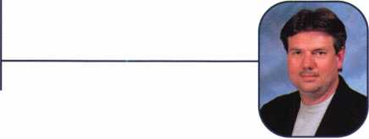

Keynotes • February 2002



CCTV Content

CCTV Calculators

Demonstration Tool

Estimation

*Drawing*

Internet Enabled

***Visit our Website on [www.stamectv.com](http://www.stamectv.com)***

**THE COMPLETE CCTV PROGRAM ON CD-RO FOR STAFF TRAINING AND PRODUCTIVITY ENHANCEMENT**

System Drawing

Estimation

• CCTV Training

CCTV Reference

**^** Sales/Demo

System Design

Staff Evaluation

STAIVI Insight has been developed to enhance CCTV skills and productivity with many different uses.

HI Productivity



**Over 50 Countries**



3003 Live Oak Street  
Dallas,Texas 75204

Name:

Job Title:

Organization: Address:

Country Tel: (

.Zip/Postcode, .e-mail

Fax: ( )

COPYRIGHT © 1996 Security Training and Marketing Pty Ltd. All rights reserved ACN 057 006 541

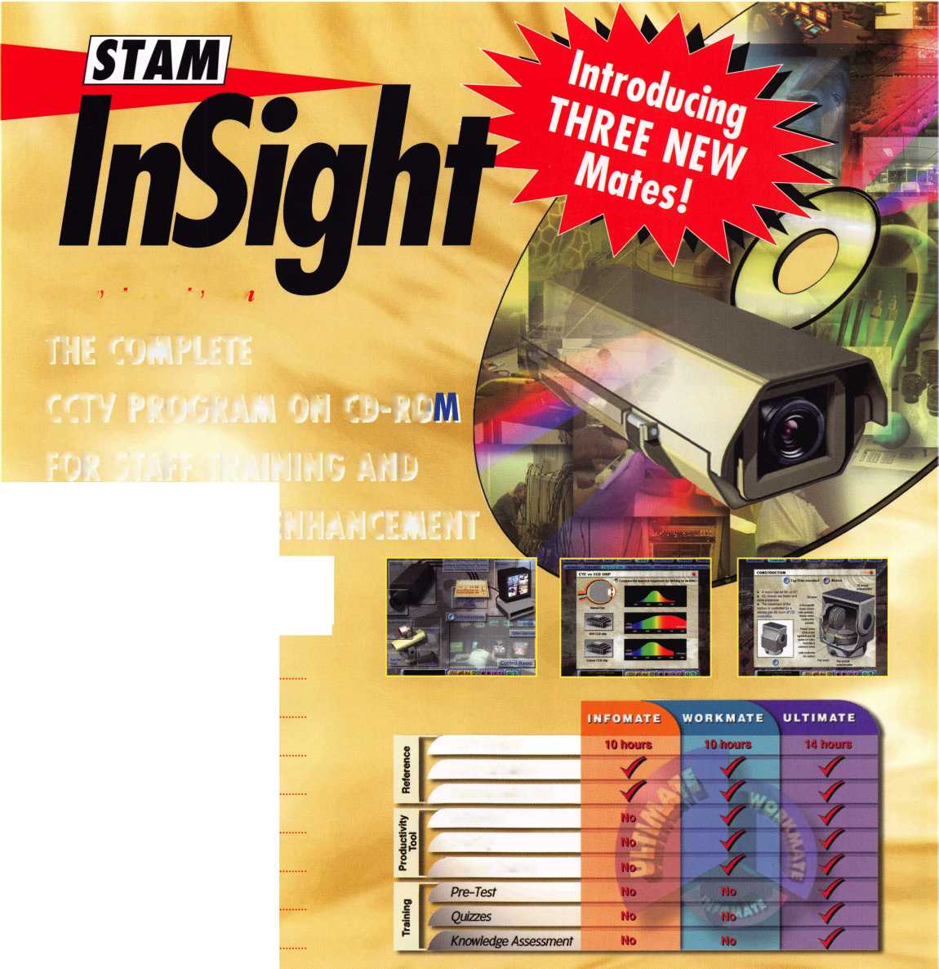

**APRIL CONT. ■ APRIL ■ MARCH CONT. ■ MARCH ■ FERUARY CONT. ■ FEBRUARY**

U p

m

n

9

PRP • Dallas, TX Ashley Manson (800) 532-ALOA (2562) [education@aloa.org](mailto:education@aloa.org)

8:00am • Indianhead/Fox Valley Chapters of ALOA Domestic Automotive Class - $85 (includes lunch) • Park Plaza Hotel - Oshkosh, Wl

Contact: Tom Vandersteen [tvanders@vansons.com](mailto:tvanders@vansons.com)

Fox Valley Chapter of ALOA Membership Meeting 6pm • Columbus Club Appleton, Wl • Contact: John Engel (731) 5400

12-17

TLA Convention, at Omni Hotel - Richardson, Texas. For more information: Michelle Spears 979-297-2413 [www.texaslocksmiths.org](http://www.texaslocksmiths.org)

PRP • Georgia Chapter of ALOA 10 a.m. • Chamblee, GA Contact John Elliott, CML, CPS 770-309-7574

16-17

Lockmasters Pure Auto Clinics San Francisco, CA Contact: Dione Alarie 859-885-6041 x316

Mount Diablo Chapter of CLA Meeting 7pm • California Maritime Academy Vallejo, CA

Contact: Art Patch, CCL, CML (707) 642-2661

Florida West Coast Locksmith Associa­tion (FWCLA) • General Meeting 8pm (Yale Locks w/Bill Williams)

Temple Crest Civic Center 512 Miller Ave. • Tampa FL Contact: Rob Curry (727) 849-1812

Southern Trade Show Southern Lock & Supply [www.southernlock.com](http://www.southernlock.com) 7:30pm - LAB Class

3-4

ALOA Board Meeting Las Vegas, NV

8

PRP • Dallas, TX Ashley Manson (800) 532-ALOA (2562) [education@aloa.org](mailto:education@aloa.org)

Florida West Coast Locksmith Association Installation Banquet Sam Seltzers • Tampa, FL. Contact: James Barnhardt 800-486-7998

5-7

ISC EXPO/West at the Las Vegas Convention Center For more information: <http://w> ww. i sc west. com

5-7

Japan Chapter of ALOA Annual Meeting Hanamaki Spa Iwate Contact: Keizo Takuhush 81-45-582-4469

^1

18-23

ACE Classes • Basic Locksmithing

Appleton, Wl

Fox Valley Technical

Jerry Antoon • 920-735-2406

920-735-2414 • antoon@foxval-

leytech.com • [www.foxvalleytech.com](http://www.foxvalleytech.com)

19

Mount Diablo Chapter of CLA Meeting 7pm • California Maritime Academy Vallejo, CA

Contact: Art Patch, CCL, CML (707) 642-2661

Minnesota Chapter of ALOA

Membership Meeting  
Broadway Pizza  
2025 West River Road  
Minneapolis, MN

18

Florida West Coast Locksmith Associ

tion (FWCLA) • General Meeting 8pi

(Detex w/Accent Marketing)

Temple Crest Civic Center  
51 2 Miller Ave. • Tampa FL

Contact: Rob Curry (727) 849-1 8

8-13

PRP* SAFETECH 2002 • Reno NV Contact ALOA • (800)532-2562 or (214)827-SAFE (7233) [www.savta.org](http://www.savta.org) [convention@savta.org](mailto:convention@savta.org)

18-21

PRP*20 ACE Classes and PRP Somerset, NJ Dan McGlynn, CML 973-267-8884 973-538-1588 [dfmcml@home.com](mailto:dfmcml@home.com) [www.mlanj.com](http://www.mlanj.com)

T

16

Mount Diablo Chapter of CLA Meeting 7pm • California Maritime Academy Vallejo, CA

Contact: Art Patch, CCL, CML (707) 642-2661

19-21

Minnesota Chapter of ALOA PRP Education weekend, Maplewood, Minnesota.

For more information: Michael Mattern, CRL (952) 544-3399

17-21

MLANJ Convention and Trade Show Garden State Convention Center and Doubletree Hotel Sumerset, NJ

|  |  |
| --- | --- |
| 1 |  |
| Minnesota Chapter of ALOA |  |
| Membership Meeting |  |
| Broadway Pizza |  |
| 2025 West River Road |  |
| Minneapolis, MN | 118# |

10

PRP • Dallas, TX • Ashley Manson (800) 532-ALOA (2562) [education@aloa.org](mailto:education@aloa.org)

**1**

16

Florida West Coast Locksmith Associa­tion (FWCLA) • General Meeting 8pm (Don-Jo w/Buddy Brown SBS Assoc.) Temple Crest Civic Center *512 Miller Tampa FL • Contact: Rob Curry (727) 849-1812

21

Mount Diablo Chapter of CLA Meeting 7pm • California Maritime Academy Vallejo, CA

Contact: Art Patch, CCL, CML (707) 642-2661



**DECEMBER ■ NOVEMBER I OCTOBER ■ SEPTEMBER ■ AUGUST ■ JULY ■ JUNE**

n t

14

PRP • Dallas, TX • Ashley Manson (800} 532-ALOA (2562)

13-14

DHI Convention and Expo,

Chicago, Illinois.

For more information: [www.dhi.org](http://www.dhi.org)

18

Mount Diablo Chapter of CLA Meeting 7pm • California Maritime Academy Vallejo, CA

Contact: Art Patch, CCL, CML (707) 642-2661

1

Florida West Coast Locksmith Associa­tion (FWCLA) • General Meeting 8pm (Steel Craft Doors w/Steve Puleo l/R) Temple Crest Civic Center 51 2 Miller Ave. • Tampa FL Contact: Rob Curry (727) 849-1 812

20

Florida West Coast Locksmith Associa­tion (FWCLA) • General Meeting 8pm Temple Crest Civic Center 51 2 Miller Ave. • Tampa FL Contact: Rob Curry (727) 849-1812

22-28

ALOA 2002

Rosemont, IL • Contact ALOA (800) 532-2562 • [www.aloa.org](http://www.aloa.org) [convention@aloa.org](mailto:convention@aloa.org)



14-16

ISC EXPO/East, Orlando, Florida

For more information: siaonline.org

19

Florida West Coast Locksmith Associa-  
tion (FWCLA) • General Meeting 8pm  
Temple Crest Civic Center  
512 Miller Ave. • Tampa FL  
Contact: Rob Curry (727) 849-1812

14-19

ACE Classes • Basic Locksmithing  
Appleton, Wl *Fox Valley Technical  
Jerry Antoon • 920-735-2406  
920-735-2414 • [antoon@foxval-  
leytech.com](mailto:antoon@foxval-leytech.com) • [www.foxvalleytech.com](http://www.foxvalleytech.com)

21

Florida West Coast Locksmith Associa­tion (FWCLA) • General Meeting 8pm Temple Crest Civic Center 512 Miller Ave. • Tampa FL Contact: Rob Curry (727) 849-1812



Florida West Coast Locksmith Associa­tion (FWCLA) • General Meeting 8pm Temple Crest Civic Center 512 Miller Ave. • Tampa FL Contact: Rob Curry (727) 849-1 812

GPL A Convention

October 23-27 (with Sunday PRP)

Philadelphia, PA

Contact: Marty Arnold, CML

|  |  |
| --- | --- |
| Don’t Miss these | |
| ALOA Events! | |
| MARCH 1 8-23 | OCTOBER 14-19 |
| ACE Classes | ACE Classes |
| Basic Locksmithing Appleton, Wl | Basic Locksmithing • Appleton, Wl |
| Fox Valley Technical | Fox Valley Technical |
| Jerry Antoon • 920-735-2406 | Jerry Antoon • 920-735-2406 |
| 920-735-2414 • [antoon@foxvalleytech.com](mailto:antoon@foxvalleytech.com) | 920-735-2414 • [antoon@foxvalleytech.com](mailto:antoon@foxvalleytech.com) |
| [www.foxvalleytech.com](http://www.foxvalleytech.com) | www. f oxva 11 ey tec h. co m |

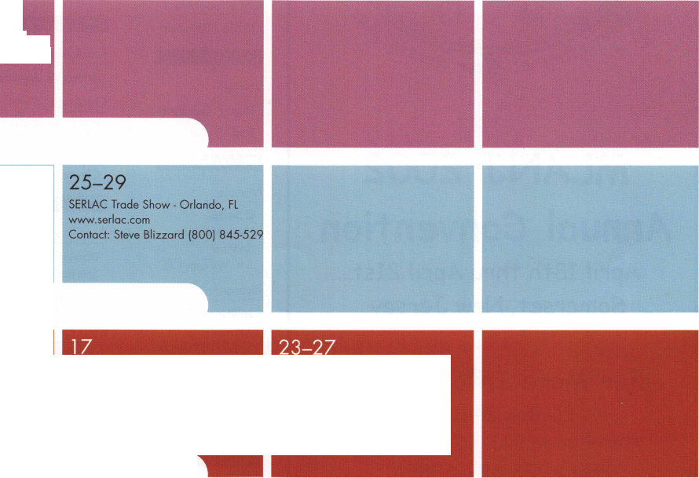

AZ

NM

West Allis

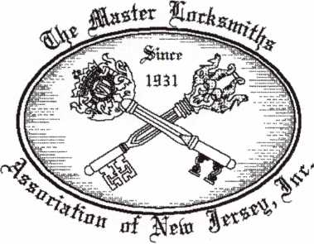

MLANJ 2002  
Annual Convention

April 18th thru April 21st  
Somerset, New Jersey

For More Information:

PO Box 2441

Morristown, NJ 07962-2441  
Phone 973-627-6385  
Fax 973-627-3246

Or visit our web site at

[www.MLANJ.org](http://www.MLANJ.org)

Springerville

Nolan Udall

CO

Colorado Springs

Floyd L. Weeks

FL

Cape Canaveral

Willis Calhoun

GA

Roswell

Rusty Gordon Tad Stahel

IN

Muncie

C Sean Hendrickson

Sponsor:

Jim Williams CRL Plymouth

Jeffrey L. Mills

Sponsor:

C Allan Halverson

**AAA**

Nutting Lake

Paul E. Broughton

**NC**

Charlotte

Joe DePaola

Creed moor

Willis Shackleford

NH

Londonderry

Richard Rogers

Albuquerque

James D. Anders

Sponsor:

Warren H. Rooks

NY

Hicksville

Brian Seidenberg

Sponsor: Joel S. Kramer

OH

Brookville

Bruce W. Jordan

Cincinnati

Kevin M. Ryan

Huntsville

Clemens Schulze

PR

Boqueron

Daniel Guido

Sponsor: Carlos Ortiz

TN

AAemphis

Harvey L. Wyrick

TX

Arlington

Jim Hurst

AAesquite

Lisa M. Richardson

Sponsor: Clifford D. Lip­scomb CML, CPS

Wl

New Berlin

David C. Bradley

Sponsor: John W. Soderland CML, CMST

Thomas W. Schmitt

Sponsor: John W. Soderland CML,

CMS7

Sydenham London

Nicholas J. Carter

Sponsor:

Paul M. Souber



Hong Kong

Wai-keung Kwok

Sponsor: Hin-chor Mak

**Japan**

Edogawaku Tokyo

Kenji Shimizu

Sponsor: Toshio Sakamoto CRL

Fuziyoshida

Yamarash

Taro Maedo

Sponsor:

Takashi Kuwana CRL  
Higashiosaka Osaka

Masahiro Satou

Nagoya Aichi

Takashi Kobayashi

Osaka-City Osaka

Kenichi Fujita

Yao Osaka

Yasuhito Matsu moto

Yokkaichi

Marui Hidenobu

These applicants are scheduled for clearance as members of ALOA. The names are published for member review and comment within 30  
days of this Keynotes issue date, respectively, to ensure applicants meet standards of ALOA's Code of Ethics. Protests, if any, should be  
addressed to the Membership Department and must be signed. Active Membership applicants (a) have worked in the industry two or more  
years. Allied Membership (AL) applicants are not locksmiths, but work in a security-related field. Apprentice Membership (AP) applicants

have worked in the industry less than two years.

Keynotes • February 2002

**Renew or Apply for Membership ONLINE at [www.aloa.org](http://www.aloa.org)**



**During times of crisis, unity is key. Right now, when you join ALOA  
(or renew your membership), you will receive, free of charge,  
this patriotic decal for your shop or van, which serves as a  
special reminder to you and your customers that it takes  
a spirited effort to strengthen the ties that bind us.**

ALUfl locksmiths

Secure America

**Decal dimensions 8'/2" x 5'/"**

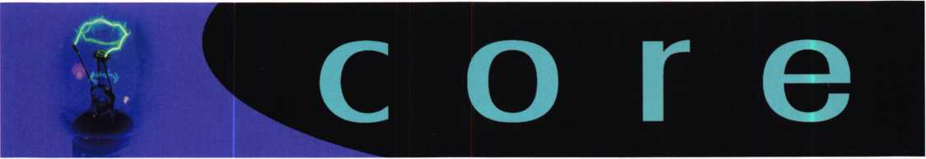

Securitron Chief Takes Medeco Reins

Robert C. Cook was recently appointed to replace Bernd-D. Wempen as the president and CEO of Medeco High Security Locks in Salem, VA. For the past 20 years, Cook has been president of Securitron Magnalock Corporation, located in Sparks, NV. Securitron is an industry leader in electronic locks and accessories used in access control systems, so Cook's appointment could mean that you can expect more electriconic locks from Medeco in the future.

Wempen will return to his native Germany, where he will assume the posi­tion of president of IKON AG in Berlin, where he previously served as vice president before moving to Medeco in 1998. Medeco, Securitron and IKON AG are all ASSA ABLOY Group companies. For more information, check the medeco web site at [www.medeco.com](http://www.medeco.com).

New Certifications

CRLs

Hans Conkel Grand Canyon, AZ

Letter to the Editor

Stealing an Entrepreneur's Livelihood?

The new-year holidays are supposed to be a festive time, it was disastrous for our family owned business. Some one or a few people decided that they wanted our tools and equipment more than we did. This heartbreak­ing event took place sometime between 10pm on Monday December 31st and 8:30am Wednesday January 2nd at Economy Lock & Key of Brandon, Inc. Our company had our two company vans, located in side a locked fenced compound, broke into by busting out the back window.

Our company has serviced the community for the past 25 yrs. We offer a quality service for a fair price. Some low life decides that if they steal our tools, it makes their life easier, but all it does is force us to have to adjust our prices to off set our loss of expensive equipment.

The perpetrators probably did not realize that they stole some where between $3500 & $4000 dollars worth of equipment. To most people it does not seem that it is worth that, but to someone in our field it is. It is sad that some low life has to start the New Year off by stealing from others.

What is this world coming to from terrorist attacks, to local low-life's stealing from honest businesses? • J. Barnhardt



CALIFORNIA A143

Requires locksmiths to be a licensed contractor or to maintain a $250,000 lia­bility insurance policy. Provides that a violation of the laws regulating lock­smiths is a crime.

01/07/2002: From Assembly Committee on Business and

Professions with amendments

01/07/2002: Read second time, amended and re-referred to

Committee on Business and Professions

ILLINOIS HB3663

Amends the Private Detective, Private Alarm, Private Security, and Locksmith Act of 1993; provides that a person who applies for licensure as a locksmith agency between September 1, 2002 and December 31, 2002 shall be exempt from the examination requirement.

STATUS: 11/06/2001 Introduced

1 1/07/2001 To House Committee on Rules

MARYLAND SI25

Continues the licensing and regulation of security systems technicians in accor­dance with the provisions of the Maryland Program Evaluation Act (Sunset

Law] by extending to July 1, 2016 the termination provisions relating to the statutory and regulatory authority of the Secretary of the State Police to license and regulate security systems technicians.

STATUS: 01/11/2002 Introduced

01/1 1/2002 To Senate Committee on Education,

Health and Environmental Affairs

OHIO HB452

Creates the Commission on Electronic Security System Regulation in the Department of Commerce. Definition of Electronic Security System includes access control and CCTV.

STATUS: 12/11 /2001 Introduced

01/08/2002 To House Committee on Commerce

and Labor

PENNSYLVANIA H2075

Regulates the licensure of electrical and alarm system contractors. Establishes the Electrical Contractors Licensing Board.

STATUS: 10/23/2001 Introduced

10/24/2001 To House Committee on

Professional Licensure

CHECK OUT ALOA'S WEBSITE AT <http://www.aloa.org/news/legcom.cfm>

FOR THE LATEST HAPPENINGS IN YOUR STATE



Keynotes • February 2002

IfTRALOtt

TOOLS LIMITED

[WWW.intralocktools.com](http://WWW.intralocktools.com)

**new**

**affordable**

**price!**

Super strong rare earth magnets

Dial gripper with reversible shaped

jaws to grip most dials

Easy to assemble mounting jig  
Self contained - no computer required

Phone:(888)264-6627 ▲ I 2639-B Progressive Ulay

(604) 852-8904 || I I Abbotsford, B.C.

(JSfl: (562) 699-0060 **TOOLS LIMITED** U2T6H8

**Seruing industry with superior products since 1985.**

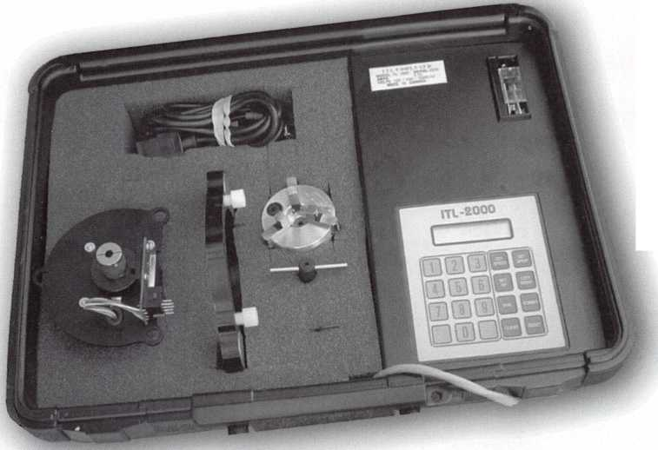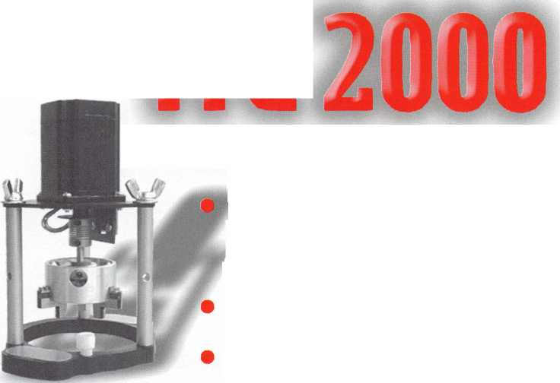

* *****

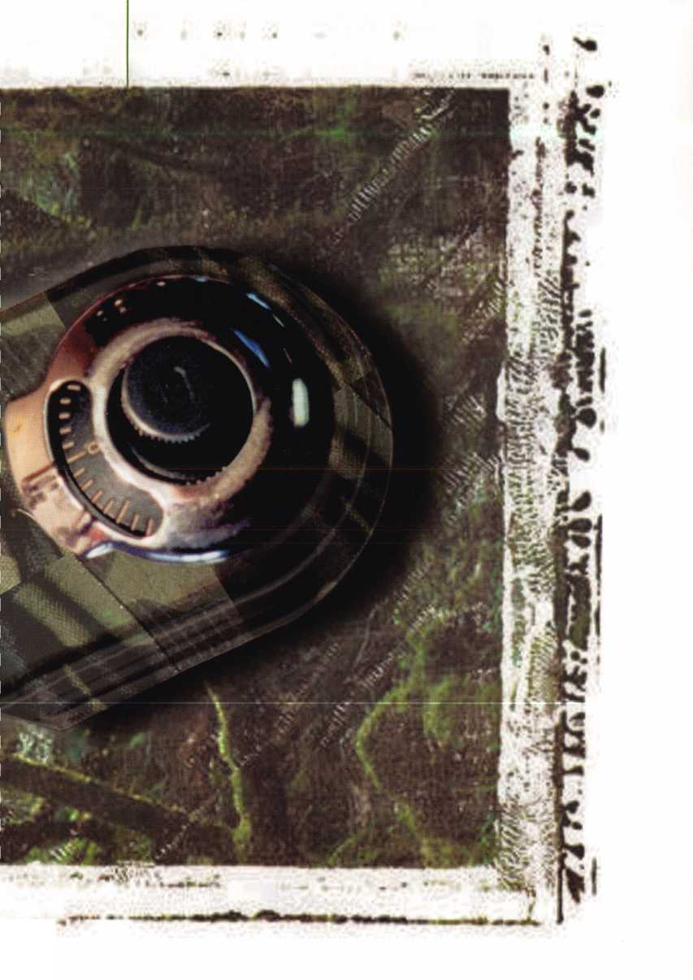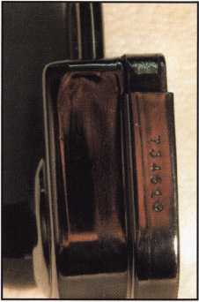

Photo 1 Photo 2 photo 3

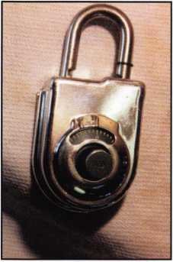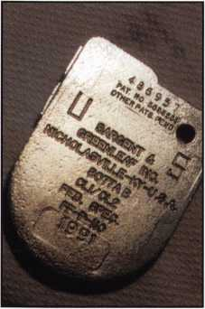

By Greg Perry CML, CPS

The S&G 8077 Padlock...Undressed

$250.00 list has always seemed like a lot of money for a padlock. Recently I was given several locked up S&G 8077AB padlocks. This padlock is the only combination padlock meeting the Military specification FF-P-110. This lock is used to secure bulky classified items where a Mas-Hamilton X-07 or X-08 safe lock is not practical. An example might be aboard a ship or airplane, for a temporary storage area or a vault is not available. I decided to see what makes them so expensive.

We’ll start with the padlock as seen in photo 1, this one is unlocked but the combination is not known. The back will come off but a shutter blocks the change keyhole. As we turn it on its side (photo 2) we see a serial number. There are three different serial numbers on each lock: the body, the back, and the shackle. These numbers, as I understand the rules, are supposed to be record­ed and kept in a separate place each time the lock is locked. When it is opened the numbers are supposed to be checked to make sure the lock has not been compromised. Before we explore the insides of the lock let me remind you that tampering with these locks in any way voids any use as an approved lock. I would highly recommend any lock opened or violated in the manner explained here be used for your personal collection or use. Do not allow it to get back into the public domain. There is too big a risk of it being reused for an approved application. I’ve used mine for a demonstration model to teach setting combinations.

The first step to working on padlock one was to drill a tiny hole in the shutter this allowed me to scope the change key hole with a otoscope just like you would side drill and scope a safe lock with a borescope. Photo 5 is of the closed shutter, photo 6 shows the hole drilled through the shutter. Once the wheels are aligned the shutter can be opened to allow the change key to be inserted. Photo 7 shows the open shutter. The change key can be inserted at this point and the combina­tion changed. After testing the combination the shutter should be returned to the closed posi­tion and the back of the lock reinstalled. It’s now ready for use as part of your collection.

Keynotes • February 2002

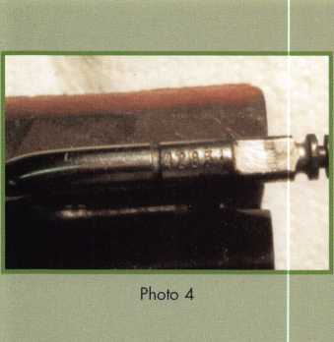

The next couple of locks were locked with unknown combinations. In this case two locks can be combined to create one non-approved lock. The first lock is drilled with a 1/4” hole through the back cover directly behind the change key shutter hole. A 3/32” is then drilled through the shutter as a peephole to view the wheels. The combination is determined as above and the lock is open. We now have a “functional lock but no back. A second lock is needed to provide the back. This time a hole is drilled in the side of the lock to view the wheels. Photo 8 shows the location of the hole. Once the combination is dialed to this hole it can be trans­ferred to the top and the lock will open. The back of this lock can now be used to provide a back for the other lock. We lose half our locks this way but half is better then none. It also leaves us a lock for disassembly.

I started by removing the chrome outer shell. This also removed the dial. Next the two rivets on the back were removed and the small pin at the top of the case seen in photo 9 was also removed. The inside back cover seen in photos 10 and 11 was removed for our first real look inside. The shackle and locking dogs are seen towards the top of the lock. The fence is a part of the locking dog assembly. Photo 12 shows the gates lined up and the drive cam in position for the shackle to be pulled up and the fence driven down into the wheel pack. Photo 14 is the wheel pack it looks a lot like a standard S&G 6730-type wheel pack with a few excep­tions. First the wheels are smaller only about 1 3/8”, sec­ond they do not have the balance holes, and third they have a notch on the side about the 4 o’clock position. This notch is used in conjunction with spring loaded fingers to scramble two of the wheels as the lock is locked. When the shackle is pulled out the fingers grab the notches in each wheel and are stretched creat

Photo 6

Photo 5

Keynotes • February 2002

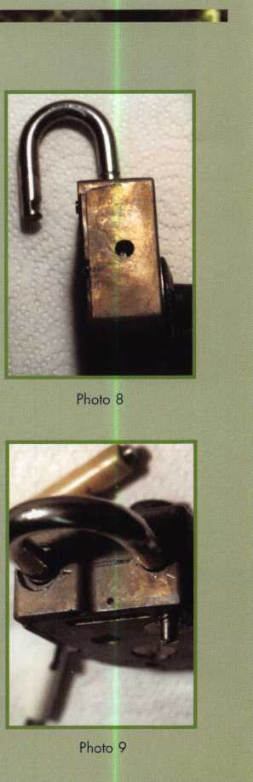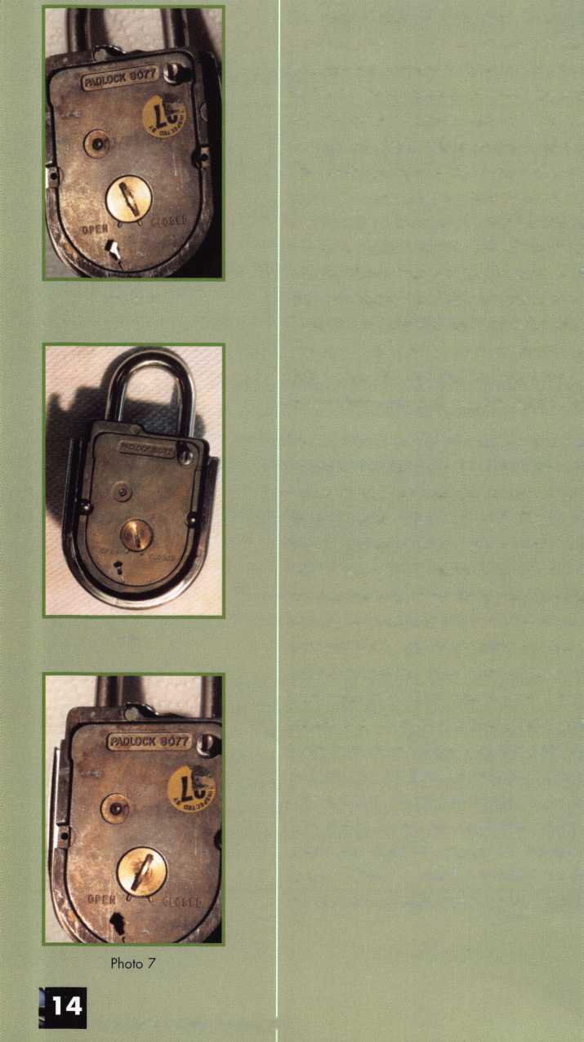

ing some tension. When the shackle is pushed into the lock the locking dogs pull the fence out of the wheel pack and the wheels are scrambled.

This lock has evolved over the years in response to var­ious concerns and I’m sure it will continue to evolve. It is not your average padlock and definitely not priced in the range of an average padlock. The purpose of this lock is to protect government secrets and provide evi­dence of tampering if they do compromise the lock. Once again if you choose to open a lock using the methods described above retire the lock from govern­ment or public service and make sure it doesn’t find it’s way back. Q

The S&G 8077AB

the only combination padlock meeting the Military specification FF-P-110.

Keynotes • February 2002

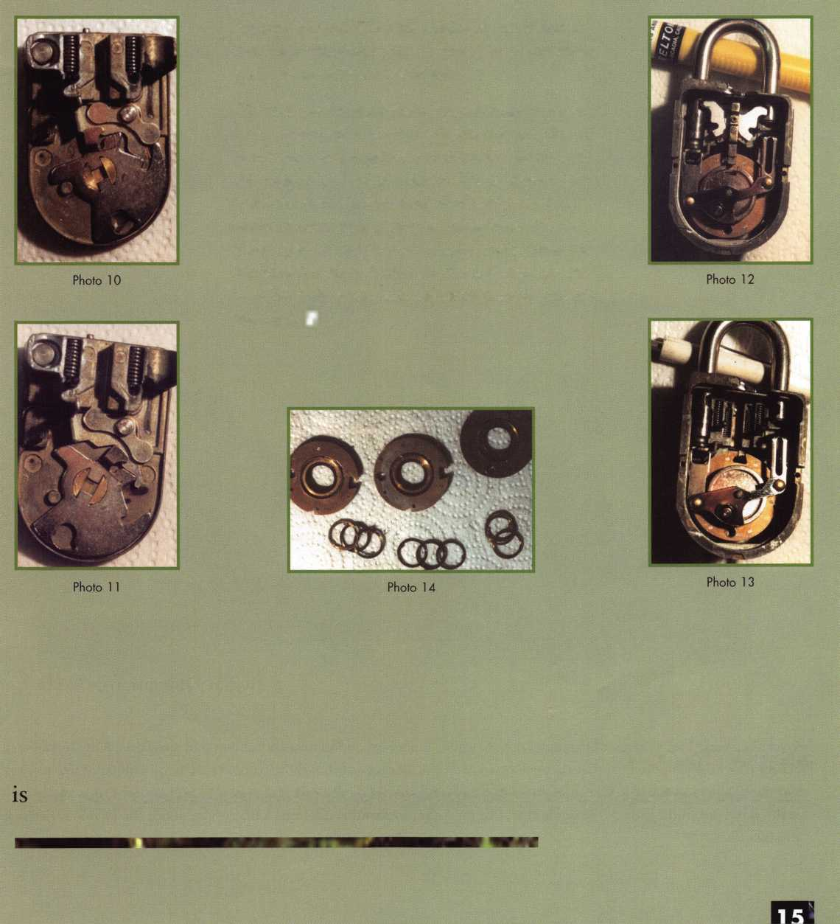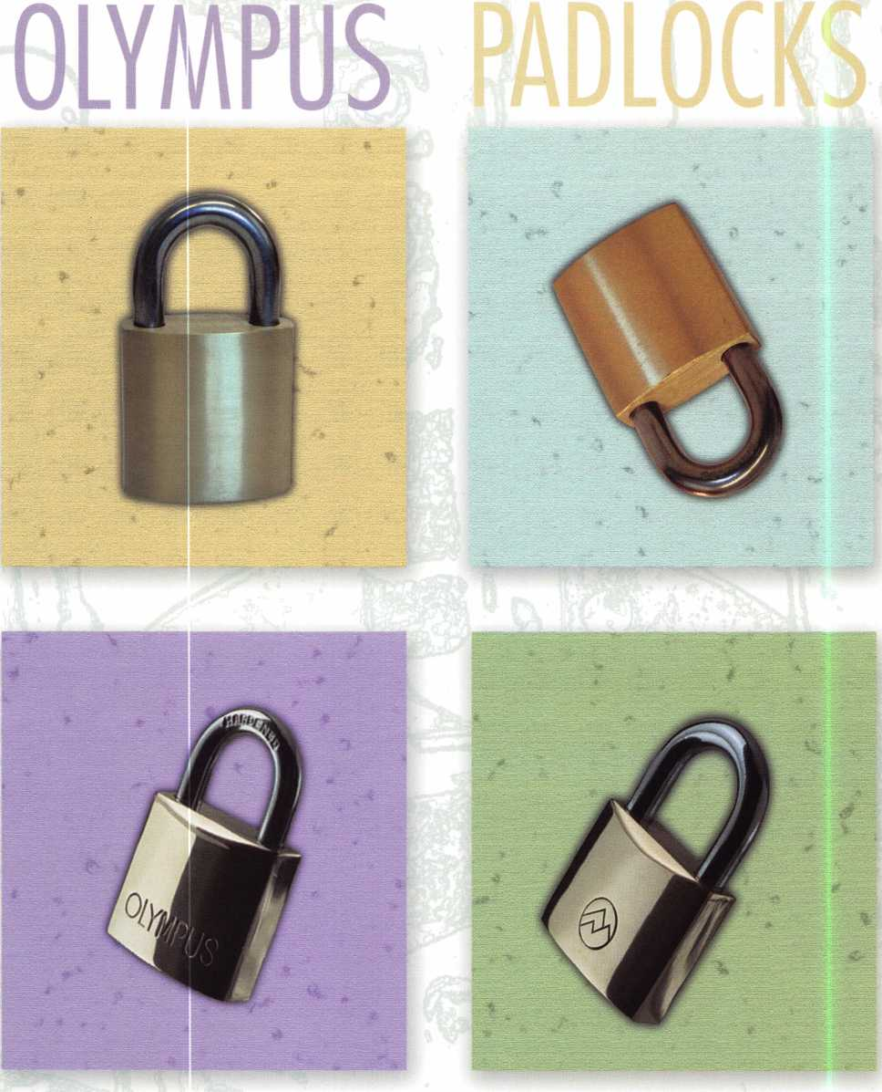

By Sal Dulcamaro, CML

Over the years, I have known Olympus Lock for their impressive and innovative cabinet and specialty locks. It was very recent that I came to discover that they even sold padlocks. Because a lot of those padlocks are fairly ordinary, Olympus has not made a big deal about it. They have preferred to emphasize their cabinet and specialty locks, because that is where they really stand out in the crowd. I imagine that, like me, other locksmiths might be a bit curious about the Olympus padlock product lines.

**16**

Keynotes • February 2002

Photograph i shows the primary line of brass non-rekeyable padlocks available from Olympus. These are not all of them, but it is a fairly good sampling of the range of sizes and options. They range in padlock body width from 3/4 inch to 2 1/2 inches. Most are only available with a standard short length shackle, but the 11/4 inch and 11/2 inch body padlocks are also available with a long shackle. These locks are not serv­iceable or rekeyable. They all use the smaller type format padlock keys; no full sized commercial keyways. These are medium priced import padlocks, and I would probably consider them by price advantage if I was going to sell this type of padlock to a customer.

There are two variations to the Olympus non-rekeyable brass body padlocks. Otherwise identical, photo­graph 2 shows a side by side compari­son of the two types. The blister packed (retail display rack type) one is at the left and the boxed type is at the right. Except for the logos, they appear to be identical. The blister packed ver­sion is called the “Mountain Series” and the other is called the “Olympus Series”. The Mountain series has a mountain logo on the face of the pad­lock body, while the Olympus series has the name “Olympus” displayed. Except for the logos, the product lines are identical to each other. The pre­sumption is that they are aimed at two different markets.

Olympus also has a relatively narrow line of rekeyable padlocks. Examples are shown in photograph 3. At the left is a long shackle version with a Schlage composite keyway. On the right is a standard shackle padlock that has a Weiser keyway. There are only a total of four variations in this brass body

padlock series. Just the two previously mentioned keyways are available, and each comes in a short and long shackle version. The brass body is 1 3/4 inches (or 45 mm) wide. The shackles have either a 1 inch or a 2 1/4 inches sized opening.

Servicing the Olympus Rekeyable Padlocks

The Olympus rekeyable padlocks are serviced similar to other brands of rekeyable padlocks. Photograph 4 shows the Phillips head screw through the shackle opening that holds the lock cylinder inside the padlock body. Once the retaining screw is removed, the cylinder will come out of the padlock.

The removed cylinder and the open cavity in the padlock body can be seen in photograph 5. Although it has a “fig­ure 8” profile like an interchangeable core, it is not IC. Notice the matching surfaces inside the padlock body and at the back of the lock cylinder where the lock actuation takes place. A “C” clip is used to retain the cylinder plug. The “C” clip has been removed in photo­graph 6.

Once the retainer is removed, the cylinder is serviced much like any resi­dential or commercial lock cylinder. A plug follower was used in photograph 7 to follow out the Weiser keyway cylin­der plug. The padlocks come standard with six pin chambers filled. If you wish to key them alike to five pin locks, you will need to empty the sixth top chamber when you empty the match­ing lower pin chamber.

The Schlage version was i-bitted; meaning that all #1 size bottom pins were used with a matching key having

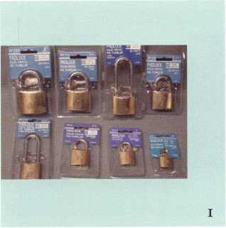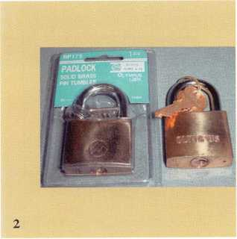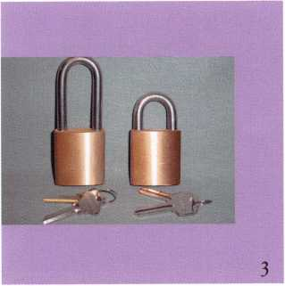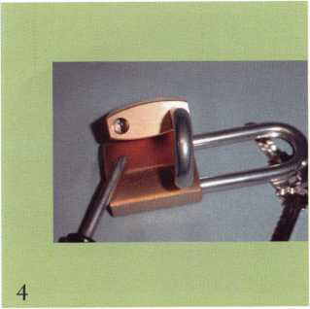

Keynotes • February 2002

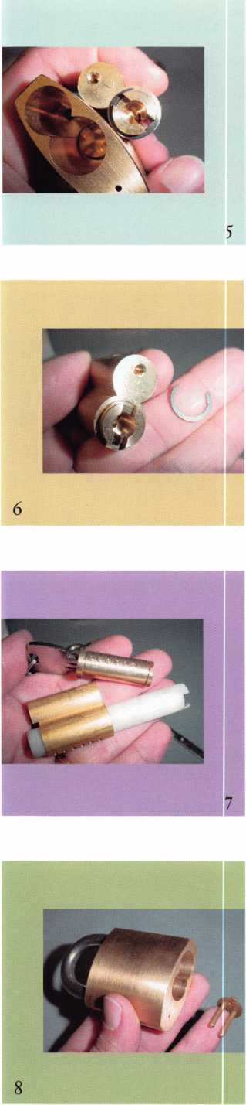

1

all #i depth cuts. That leaves you with nearly a “blank” key which you can re­cut to whatever depths you need (except for zero depth, which would be too shallow). The Weiser version appears to be cut just a bit more shal­low than a zero depth. You should be able to re-cut the Weiser type key to any bitting pattern. The Schlage ver­sion has a composite keyway, even though the key included is the stan­dard “C” keyway. Most standard (non- Everest) Schlage commercial keyways should be compatible with the com­posite pattern.

A slight warning on the servicing end. The Olympus rekeyable padlocks are somewhat “retro” when it comes to serviceability. A lot of the other brand rekeyable padlocks have evolved to the point of being nearly goof-proof. The Olympus padlocks remind me of some of the other brands back a generation or two on serviceability. They are a bit more awkward to service, and without quickly changeable shackles.

There is a disc-like actuating piece inside the padlock body that translates the rotation of the lock cylinder plug to the release of the shackle. When the lock cylinder is removed, that disc shifts slightly and interferes with the full re-insertion of the cylinder back into the padlock body. I have found that closing the shackle first helps the disc to move out of the way to allow full insertion. In order to close the shackle though, the attaching screw must be left out. That means that you lock the shackle without the cylinder being retained yet. Then you turn the key to unlock it again, while holding the cylinder in all the way so it doesn’t push back out slightly. With the shack­le open, you can reinsert the screw in

the shackle hole and tighten. If you allow the cylinder to shift and back out slightly again, you may have to repeat the procedure.

If the disc comes out completely, you may need a pair of tweezers to reinsert it up into the padlock cylinder cavity. With the disc out, the toe side spring catch will travel part way into the shackle hole. You will need to push the catch mechanism back inward to allow the disc to seat properly. If you can re­lock the shackle, that will keep the spring catch from moving out of place. Although a bit awkward, it was nowhere near some of the nightmare experiences I’ve seen with some earlier generation rekeyable padlocks sold by some other companies.

Corbin/Russwin IC Compatible Padlocks

Although I found the previous padlock offerings from Olympus just interest­ing, one of their padlocks really stands out. While it seems that everybody and their uncles are making padlocks that are compatible with small format (Best-style) interchangeable cores, I don’t recall any of the padlocks being compatible with other IC formats such as Corbin/Russwin— until now. Photograph 8 shows the Olympus brass body padlock for Corbin/Russwin IC. It has a 2 inch wide body (50 mm in metric) and two shackle sizes are offered. One shackle has about a 3/4 inch (20 mm) clearance and the other about 1 inch (25 mm). The shackle diameter measures about 11/32 inch, which appears to be the same thickness as for the rekeyable padlocks mentioned earlier. The shackles indicate stainless steel rather than hardened.

**8**

Keynotes • February 2002

Photograph 9 shows a Corbin/Russwin I-Core that has been partially with­drawn from a Corbin/Russwin housing. The holes in the back of the I-Core, in photograph 10, show where the drive pins enter the plug which allows key operation of the I-Core to actuate the lockset in which it is installed.

The Corbin/Russwin mortise housing has the two drive pins permanently attached. The drive pins are separate (non-attached) parts to the Olympus IC padlock. The part holding the drive pins must first be inserted into the back of the Corbin/Russwin I-Core, before the I-Core can be inserted into the housing (padlock cylinder cavity).

Photograph 11 show the “figure 8” opening within the padlock body and the Corbin/Russwin I-Core with the driver piece attached. The actuating piece within the padlock body is verti­cal. The raised tabs on the back surface of the driver piece are directly in the path of the actuating piece and won’t maneuver around it to allow full inser­tion of the I-Core. Take a long nose pliers or tweezers (or other suitable tool) to turn the actuating piece manu­

ally and the padlock will unlock and release the shackle. When unlocked, the actuating piece rotates slightly, as shown in photograph 12. The I-Core will now fully insert. The Corbin/Russwin I-Core has been installed in photograph 13.

While cabinet and specialty locks will always come to mind first when I think of Olympus Lock, I now know about their padlock line. Although the pad­lock product line is mostly ordinary, the Corbin/Russwin IC padlock is an eye opener. While you may consider and price shop the rest of the padlock line, I don’t know of any other source for Corbin/Russwin IC compatible padlocks outside of Corbin/Russwin (if they make them).

For more information about all of the Olympus product line (they make some really great and innovative cabi­net locks), contact Olympus Lock, Inc., 2720 N.E. 115th Street, Seattle, WA 98125-5316. Phone: 206/362-3290. Toll Free: 800/525-0954. FAX:

206/362-3569. Web site: [www.olympus- lock.com](http://www.olympus-lock.com) . Q

Contact the  
author online at

http://home.earth-

link.net/dock-

writer

Keynotes • February 2002

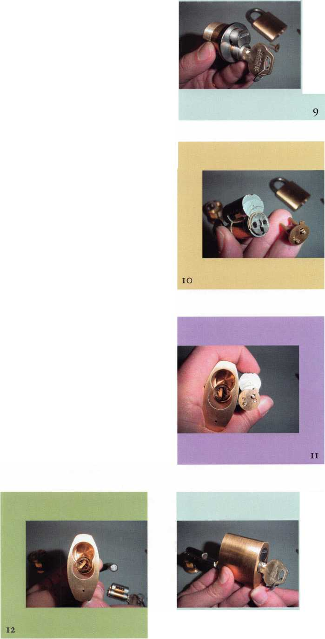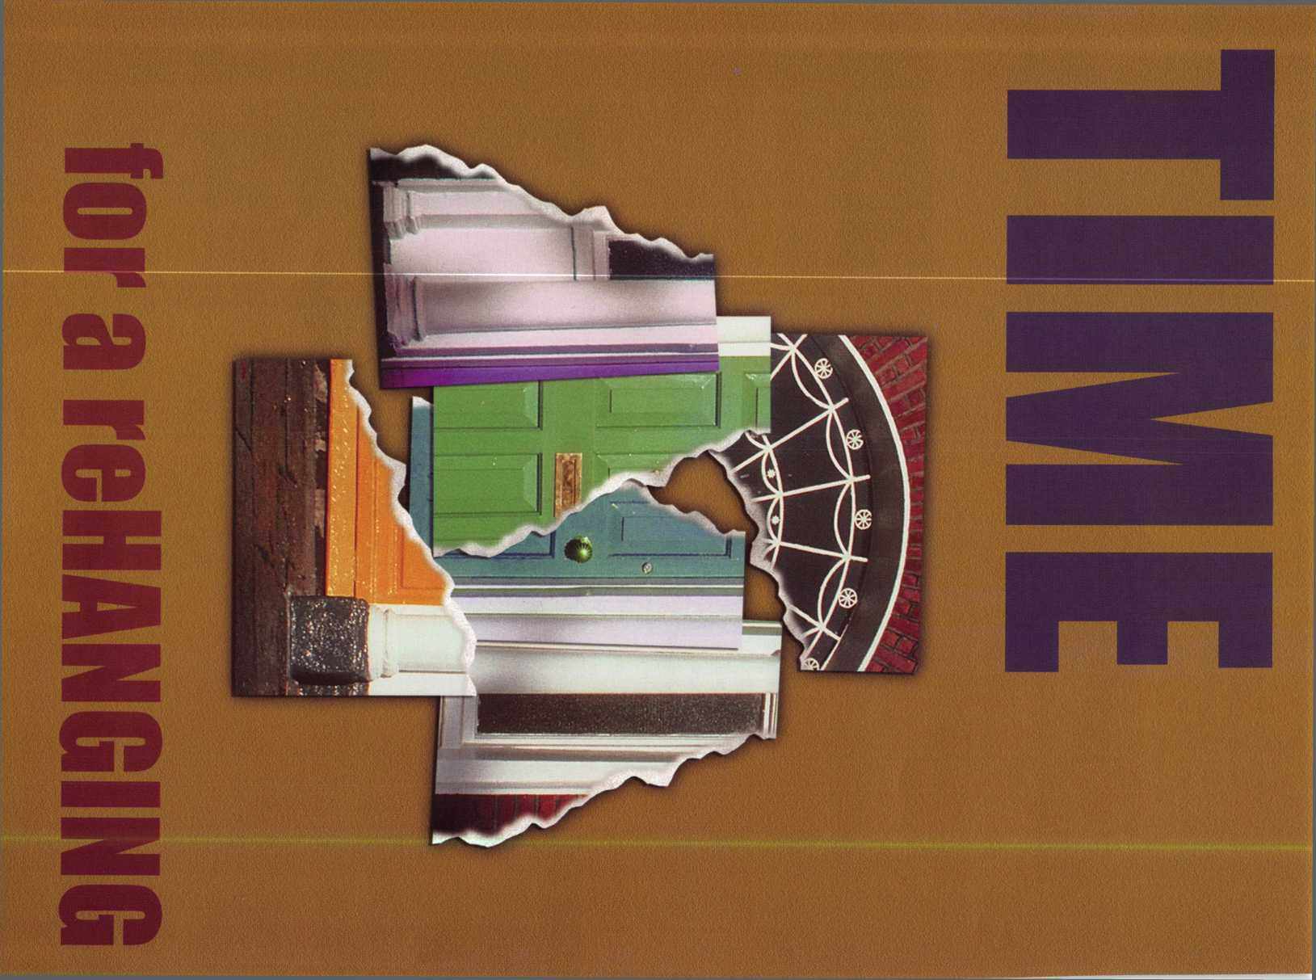

Our customers, although reluctant at first, have expressed complete

satisfaction with the completed installs.

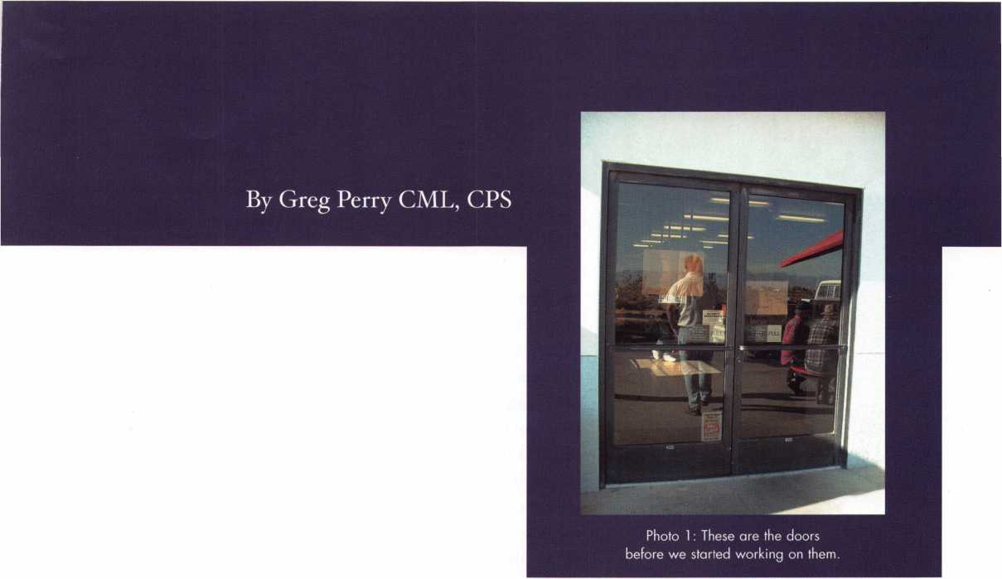

She was tired of all the trouble the pair had been giving her, hitting her and her customers. It was time for another (re)hang- ing. We already re-hung one pair for her last year and now she wanted this pair re-hung too. The closers were worn out and the pivots were shot. Originally the doors were hung with center hung concealed overhead closers. Because of the windy environment we live in, these closers rarely last longer than a year or two before the spindle seal starts leaking. As the hydraulic fluid leaks out the closer starts closing the door faster and faster until pretty soon the door is hitting people as they walk through the door. We offer two solutions, replace the closer every couple of years, or remove it completely and hang the doors on Select continuous geared hinges with LCN 4111 surface mount door closers. The first method costs about $500, the second is $1700, most customers hoping to save money choose the first. A year or two later they call us back to do the second. This customer was smart; she had already seen how often the previous owner had changed closers and decid­ed to try our option two on her front doors a year ago. They worked so well she now wanted the side doors done.

Keynotes • February 2002

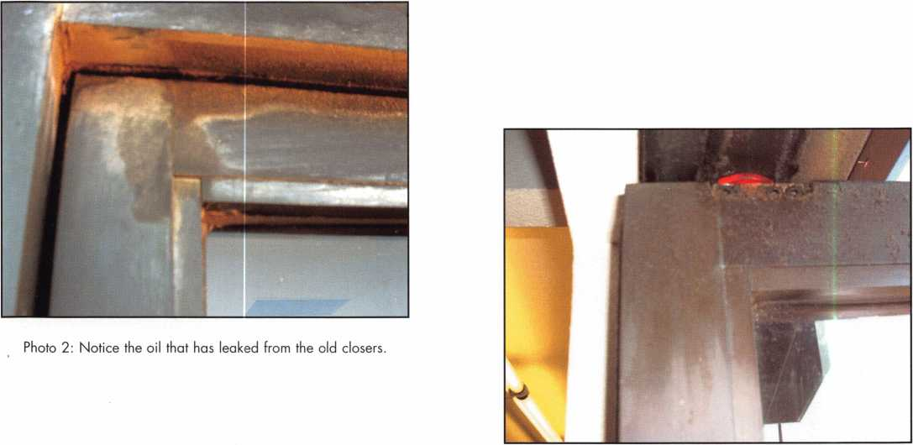

Photo 3: Remove the screws to remove the door.

We started by removing the doors; this allowed us to remove the snap  
in covers revealing the closer seen in photo 4. We removed the leaking  
closers and cleaned the header, frame and door of the leaked out  
hydraulic fluid. Placing the hinges on the doorframe we aligned the top  
of the hinge 1/8” down from the top of the door opening. We drilled a  
couple of holes for the screws one at the top and one at the bottom and  
installed the screws. Before finishing the screw holes we checked the  
hinges for proper alignment and free movement. We used a universal  
self-centering transfer punch seen in photo 5 to mark the center of all  
the hole locations and finished installing all the screws. The doors were  
put in place resting on some shims to align them in the opening. We  
adjusted the door position with the shims and installed a couple of the  
small screws in each door. Removing the shims we checked the doors

Photo 4: This is the old closer after removing

the snap track cover. for alignment and operation. The inactive door was a little close to the

frame at the bottom. We removed the bottom screw and shifted the  
door over with a shim between the door and frame. A new screw hole was drilled and a screw was installed. This time when  
we checked the doors they aligned properly. The rest of the fasteners were installed and we added some steel pop rivets

between them for extra support.

The header posed some problems. Normally when we remove a concealed closer we install a sheet  
metal “bridge”, as seen in photo 6, we have made to provide something for the parallel arm shoe  
screws to attach to inside the header. It is attached to the face inside the frame. The snap in piece will  
pull out and offers no support. This header is made different than most. It has a 1/4” return on the  
underside from each face preventing the use of our “bridge”. Instead two pieces of 1/4” X 1 1/2” alu-  
minum angle were installed, the first with one side to the top and the inside face. The second needed  
1/4” trimmed on one side; it was then mounted to the inside of the first piece with the larger side

Photo 4: a  
universal transfer  
punch, available  
from most tool  
supply stores.

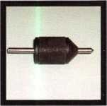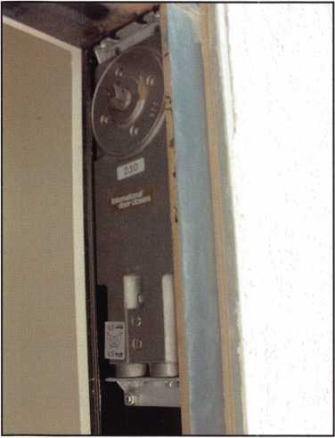

**22**

Keynotes • February 2002

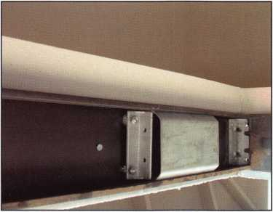

Photo 5: This is the sheet metal bridge we  
normally use to provide support inside the  
header. This header has returns which forced  
us to make a different style support.

pointing toward the outside as seen in photo 5. A third piece was cut  
with a 45-degree return at each end and installed on the inside face  
creating a sandwich of aluminum. The pieces were pop riveted in  
place. This provides a strong mounting plate for the parallel arm  
shoe. The snap track was reinstalled and one hole for the shoe was  
drilled. A screw was installed through the shoe and the center punch  
was used to mark the other locations. These holes were drilled and  
tapped through both pieces. The arm was removed and installed on  
the closer. This is a one-piece arm so the arm must be installed on  
the closer before attaching the closer to the door. A LCN 4010-18  
drop plate was mounted to the door, again only one hole is drilled  
and a nut-sert installed into the aluminum to provide a thread. The  
plate is installed and the other holes are marked and drilled. Three  
extra 3/16” holes for pop rivets are drilled since two of the drop plate  
screw holes cannot be used. The drop plate is now firmly attached  
to the door and the closer with the arm attached is mounted to the  
plate. The arm is pulled around to allow one hole of the parallel arm  
shoe to be started. Then swing the arm around some more and  
install the balance of the screws. Three additional holes are drilled  
and pop rivets installed between the shoe and the inside face alu-  
minum angle for extra strength. Our last step is to install a pair of  
aluminum handles. We live in the desert where temperatures can  
soar well over 100-degrees. Duranotic or dark brown handles will  
burn you in the summer time.

We’ve installed this package for over 8 years. Our only failures have  
been one header coming loose and before we started using the LCN  
4111 we used the LCN 4041 closer. The standard arm, screws to the  
parallel arm shoe, a couple of these screws pulled out. We installed  
longer screws and added a nut to prevent the pull out. Our cus-  
tomers although reluctant at first have all expressed satisfaction  
with the completed installs. Q

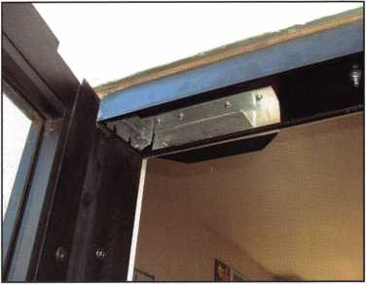

Photo 6: This is the aluminum installed to  
support the parallel arm shoe.

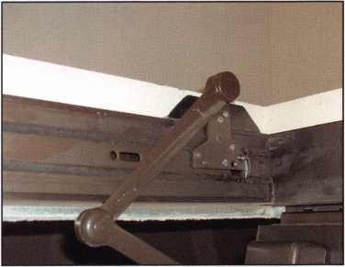

Photo 7: The parallel arm shoe is installed  
after the snap track is put back.

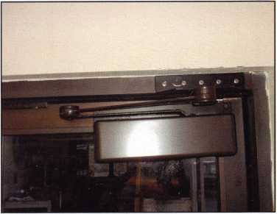

Photo 8: This is the completed install of  
the closer and shoe.

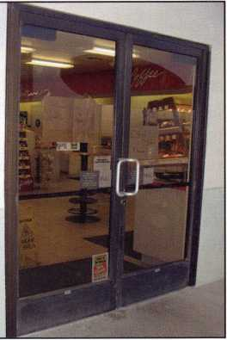

Photo 9: The completed doors,  
as seen from the outside.

Keynotes • February 2002



Servicing the Amsec BWB3020 By Milton Wolferseder

The Amsec Safe Company is one of the leading manufacturers of safes in the  
country today Their line is very broad and extensive. One particular safe in their  
line, which is very widely used, is their model BWB3020 (photo 1). This partic-  
ular safe, which is a non-insulated model, is perfect for storing cash drawers, reg-  
ister trays and other items that do not require maximum burglary protection.  
These are “B” rated safes with a full 1/2-inch thick door. The doors are recessed  
to resist prying and the combination lock is protected by a formidable, drill-  
resistant hard plate. If, in a burglary, the combination lock is punched or over-

stressed, there is a high quality secondary relocking device that is activated automatically, and which deadlocks the bolt  
mechanism. The locking of the solid steel door is controlled by five 3/4-inch thick diameter deadbolts. These active bolts  
lock the door on the top and bottom, as well as on the opening edge (photo 2). In this particular model, the S&G combina-  
tion lock faces downward, with the locking bolt engaging the main door bolt master plate. This control master plate moves  
from left to right, and when the combination lock bolt is in a locked mode, fully extended, it remains trapped in the cut out  
in the door bolt master plate. Photo 3 shows the locking arrangement. Only when the combination lock bolt is opened can  
the master plate with the door bolts attached move over to an open mode. Notice also in photo 3 the position of the relock-  
er pin. This spring-loaded relocker is snugged along the right side of the combination lock as you would see it from the out-  
side looking in. The relocker does not deadlock, and can be lifted. When activated, this dead relocker rests behind the back  
edge of the master plate, just above the area with the slide bearing pin with the cotterpit. Photo 4 shows the top door bolt

3

H Keynotes • February 2002

**2**

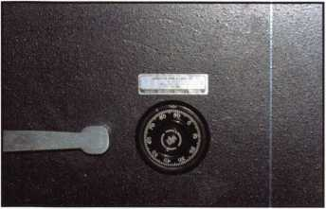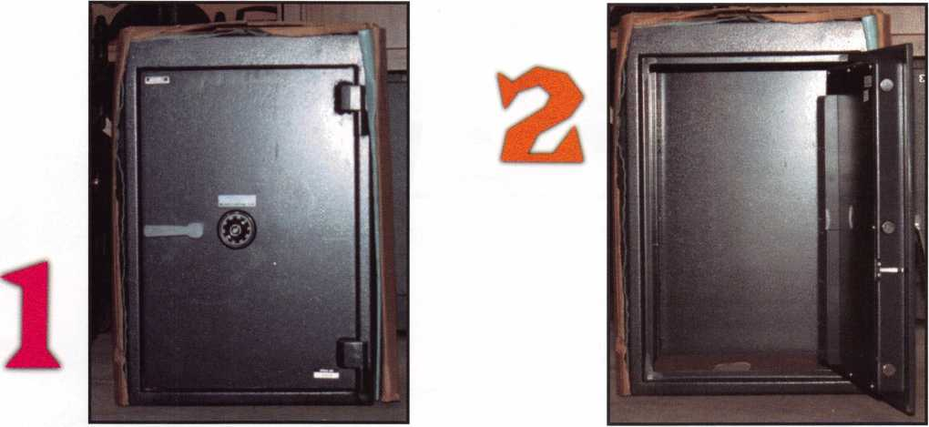

and a good view of the master slide with the lock facing downward. If the safe requires opening because of a lost or unknown combination, these group 2 locks can be manipulated if you have the expertise for such procedures. Otherwise, drilling is your only other manner of entry First, remove the dial with a dial puller and unscrew the dial ring. Mark and drill a small 1/4-inch diameter hole (larg­er hole for those more comfortable with it) 7/8-inch to i-inch due left of center at the 9 o’clock position. Sight the wheels and lien them up under the fence of the lever. You may be required to shift the read­ing slightly, one number up or down, until the lever pops in. If the safe had been burglarized, chances are that the relocker pin has released and fired. In this situation, you must also drill for the relocker pin. The relocker pin is held cocked by an extension finger built into the lock back cover. (See photo 3 again.) Mark and drill a comfortable hole 2 1/2-inch- es down from the dial center and 1 3/4-inches to 2 inches to the right. You will be penetrating a 1/2- inch thick door and then a thin hard plate. Once through the hard plate, the round relocker pin will come into view. Lift it up with a steel probe and at the same time, press down on the outside bolt con­trol handle to release the door bolts. Restore the integrity of the safe by welding up the holes after inserting hard steel ball bearings in them. Grind smooth and repaint to perfection. Q

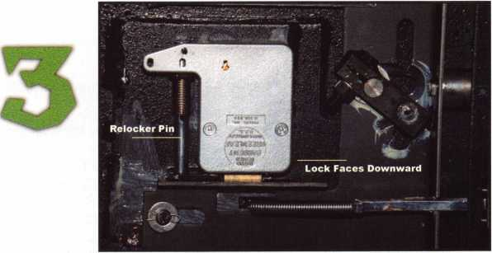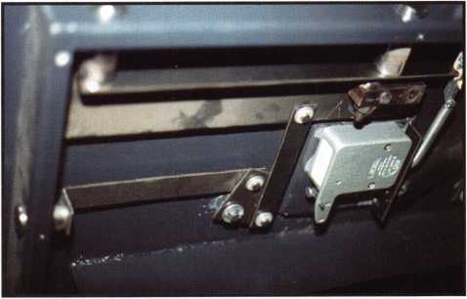

Keynotes • February 2002

Look for the SHDA logo as your assurance of a member company providing value-added features, helping to reduce your costs.

For more information on our organization, visit our website shda.org or contact us.

Security Hardware Distributors Association

1900 Arch Street Philadelphia, PA 19103-1498 Phone: (215) 564-3484 Fax (215) 963-9784 E-mail: [shda@fernley.com](mailto:shda@fernley.com)

**Reducing your costs...increasing your profits**

Security Hardware Distributors Association

The total cost of doing business includes dozens of factors that may never appear on your books. Consider the value-added benefits of working with SHDA member companies. You may get extra services, features, and add-ons with the products you order. These value- added extras may minimize your total cost and enhance revenues.

Manufacturers realize that distributors perform many value-added services for them. These services include:

* Buy in large quantities...reducing costs for both them and the end user
* Facilitate cash flow by reducing the number of accounts to whom they sell
* Provide an important link to their marketing strategies for goods and services
* Provide education and support to the user
* Provide on-going communications, including marketing date, recognizing product needs to the industry
* Provide product, parts and service from local stock that speeds delivery at reduced costs to all parties

\ i \i / \

These value-added services, and other, are realized by the following Associate Members of SHDA:

A-1 Security Manufacturing Corporation • Abloy Door Security North American Division Abus Lock Company • Adams Rite Manufacturing Company • Adesco Safe Manufacturing Company • Alarm Lock Systems, Inc. • American Eagle Lock Co. • American Lock Company • American Security Products Co. (AMSEC) • Architectural Control Systems,

Inc. • Arrow Lock Corporation • ASSA, Inc. • Auto-Security Products (ASP Inc.) • BWD Automotive Corporation • Cal-Royal Products, Inc. • CCL Security Products An Eastern Company • Compx Security Products • Detex Corporation • Don-Jo., Inc. • Door Controls International • DORMA Architectural Hardware • Dynalock Corp. • ESP Lock Products,

LLC • Falcon Lock • Gardall Safe Corporation • Glynn-Johnson • H.E.S./Hanchett Entry Systems, Inc. • HPC, Inc. • llco Unican • llco Unican Corporation • Intellikey Corporation

* International Electronics Inc. • Jackson Corporation • Jet Hardware Mfg. Corp. •

Keedex, Inc. • KSP (Killeen Security Products) • Kwikset Corporation A Black & Decker Co. • LaGard, Inc. • LAB • Laser Security Products • LCN • Locknetics Security Engineering • Lucky Line Products, Inc. • M.A.G. Eng. & Mfg., Inc. • Markar Products • Marks USA • Mas-Hamilton Group • Master Lock Company • Medeco Security Locks Inc. • MIWA Locks U.S.A. • National Guard Products, Inc.

* Olympus Lock, Inc. • S. Parker Hardware Mfg. Corp. • PDQ Manufacturing • Perma-Vault Safe Corp. • PRO-LOK • Rockwood Manufacturing • Rofu International Corporation • RCI/Rutherford Controls
* SAFLOK • Sargent & Greenleaf, Inc. • Sargent Manufacturing Company, Subsidiary of ASSA Abloy Inc. • Schlage Commercial •

Securitron Magnalock Corporation • Strattec Security Corporation • Super Lube • Supra Products, Inc. • Trans-Atlantic Co. • Trine Access Technology • Von Duprin, Inc. • Wilson Bohannan Co. • Yale Security Inc.



“DOM” Hubcap Lock

Fig. I

By Red Howell, CRL, ACE Instructor

Have you ever had a  
high end vehicle roll  
into your shop to be  
serviced for secu-

rity? One of the

many temptations

(among them is  
hopping in, firing  
her up and head-  
ing for Mexico) is

to focus just on keep-  
ing the car from being stolen. You may not even give the  
wheels and hub caps - a prime target of burglars - a sec-  
ond glance. OK, maybe not a third glance.

Rolls Royce and Bentley cars use the “Dorn” cam lock to secure those fancy hubcaps to the fancy wheel rims on their fancy cars. The Dom cam lock in this article turns counter clockwise and is a four-chamber cam lock using key blanks DM31, or DM110 by Ilco.

Fig. 2

The bottom of the plug housing has five holes, but only  
the first four chambers have four-top and bottom  
pin. The fifth chamber has a control pin that

allows the plug to turn only 90 degrees to the  
left to remove the hub cap. The code is  
stamped on the side of the plug housing 80  
to 90 percent of the time.

Figure 1 shows the wheel rim, with the  
hub cap in the center. (Sometimes the hub  
cap will cover the entire rim.) The plastic  
cap at the bottom of the hub cap in this  
illustration is to protect the lock from dirt  
entering into the keyway. (The lock may dry out;

cleaning and lubricating the lock will be a good idea  
before working on it.)

Figure 2 shows the side view of the plastic cap and its

Keynotes • February 2002

**2**

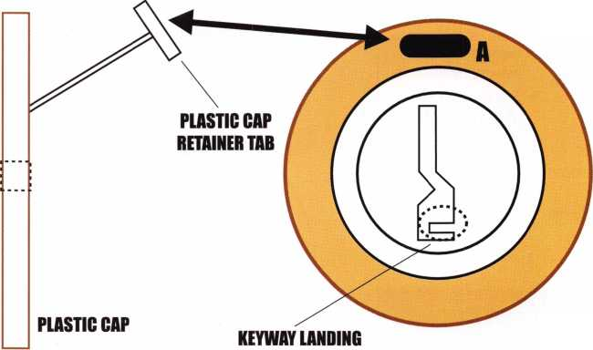

B

I

C

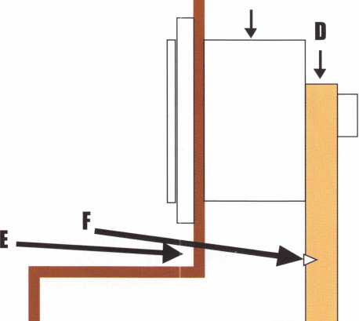

**i**

Fig-3

retainer tab. The retainer tab is inserted into Figure 2-A.  
With a small, handmade tension wrench, and a small,  
handmade half-diamond pick, the lock can be picked.

Figure 3 shows the side view of the hubcap cavity where  
the lock is housed. If you cannot pick the lock, there is  
another way to pick and turn the lock. Looking at the side  
view of the lock, you can drill a hole under the bottom of  
the lock, through the hub cap shell and inside the cavity.  
After drilling the hole, you can see the lock’s tail piece.  
Using a smaller drill bit, drill an indention into the tail  
piece.

Figure 4 shows the first hole you drilled and the smaller  
intention you placed into the tail piece. With a sharp  
object placed into the small indention that you placed into  
the tail piece, apply light turning pressure in the counter-  
clockwise direction. (The face of the plug should be turn-  
ing clockwise.) At the same time, pick the pin tumblers.  
After removing the hub cap, remove the lock from it and  
if there is a code on the plug housing, cut by it. However,  
if the code is not on the side of the plug housing, impres-  
sion a key or take the lock apart. To remove the plug from  
the plug housing, you must first find the control pin (up  
inside the fifth chamber). Push in on the control pin.

Then, at the same time pick the plug to

DESKTOP

DISPATCHER

CHECK OUT THESE GREAT ADD-ONS!

MAKES WORK  
A BREEZE!

A.I.M.

(AUTOMATIC INVENTORY  
MODULE)

Automatically deduct parts sold  
on each work order from your  
inventory. Look up features  
allow you to find just the part  
you're looking for. Over 8000  
locksmith related parts already  
entered for you. *$125.00

INVOICE MODULE  
Create, store, and print invoic-  
es with the click of a button.  
The invoice is built from the  
information you already  
entered on the call. Plus you  
get Thank You letters, late  
notices, statements, and tax  
and income reports.  
$125.00

CALLER ID MODULE  
Take a message with the mes-  
sage board or create a new  
call and have the phone num-  
ber, name and address entered  
for you with the click on one  
button. (Call for pricing.)

ACCOUNTS PAYABLE MODULE  
Do you use sub contractors?  
This handy module ties into  
the invoicing module to track  
the money you owe your subs  
as well as other payables. (Call  
for pricing.)

Shows the customer's service history right on the screen as you enter a new call.

Keep track of your cus­tomer's key codes, com­bos, and equipment.

Unlimited number of calls or customers.

Tracks all your complet­ed calls for quick retrieval and reference.

New Calendar screen allows you to view

appointments in a list view and even reassign or reschedule appoint­ments without having to switch back and forth between screens.

* Improved List View allows the dispatcher to locate any technician at a glance.
* New layout in the cus­tomer list allows you to store photographs and audio notes of your cus­tomer's equipment

Desktop Dispatcher is your windows-based solution for  
creating, tracking, sorting and printing work orders and  
customer lists.

Get it Now for Only 250.00!

Comparable to other programs selling for $1500.00

the right and then with a small follower and shim, remove the plug from its hous­ing. One last bit of advice and you’re home free with the servicing aspect of this gor­geous car. When removing the plug, do not let the bottom pins fall out.

Until next time, happy sailing.

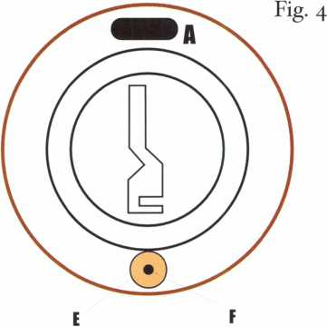

Keynotes • February 2002

mgmsm.

**wfSfeiWM**

A

Take

**1 5% off**

list price!

of Our Titles...

Learn About Basic Electricity 29.95

Spacing and Depths, vol 1 19.95

Spacing and Depths, vol 2 19.95

Filing for Dollars 29.95

Antique Padlocks 29.95

VATS Made Simple (Revised) 29.95

Guide to Transponders 79.00

2000 Transponder Update 45.00

Bread & Butter 85.00

Locks and Lockmakers of America 19.95

Learn About Electronic Locking Devices 29.95

The Best of Locksmithing, vol 1 19.95

Logical Lock Diagnostics 29.99

How to Pick Lever Locks 19.95

Fundamentals of Master Keying 55.00

Guide to Electronic Locksmithing 39.95

Security Solutions Locksmith Marketing Program 89.95

The Ultimate Techtips Collection 39.95

PRP Resource Guide 25.00

Locksmithing from Apprentice

to Master 27.00

Wafer Lock Reading 19.95

Door Lock Encyclopedia 39.95

Lock Repair Manual 14.95

Interchangeable Core Cylinders 34.95

Picking & Impressioning 45.00

The Lure of the Lock 29.95

High Security Safes, vol 1 175.00

High Security Safes, vol 2 175.00

Safeman's Guide, vol 13 9.95

Safe Deposit Depth and Space Manual 99.00

Safe Technician's Reference Manual 155.00

Gun Safes 1 10.00

Modern Safe Opening 59.95

Dave McOmie on Vault Doors, vol 1, Bank Vaults 1 10.00

Dave McOmie on Vault Doors, vol 2, Fire and Plate Vaults 1 10.00

Modern Safe Locks 95.00

Drilling Safes 95.00

Safe Deposit Box Service 39.95

Foreign Car Impressioning Book 29.95

Impressioning Ford and GM Side Bar Locks 29.95

Automotive Lock Servicing Update #1: GM 10-Cut Locks 29.95

Automotive Lock Servicing Update #2: GM 10-Cut Locks 29.95

Automotive Lock Servicing Update #3: GM 8-Cut Locks 29.95

GM Locks: Perfect for the Beginning Locksmith! 29.95

Ford Locks: Pin Tumbler and Ten-Cut Systems 29.95

Chrysler Pin Tumbler Locks 29.95

Chrysler Double-Bitted Locks 29.95

Toyota Split-Tumbler Locks 29.95

Basic Door Panel Servicing 29.95

Advanced Door Panel Servicing 29.95

Motorcycles on CD 99.00

The Guide to Motorcycles 99.00

Japanese High Security Auto Servicing 29.95

Revised GM Steering Column Course 1 15.00

Foreign & Domestic Auto Service 69.95

Auto Lock Service 14.95

The Sieveking Auto Key Guide & Illustrated Cross Reference 27.00

Servicing Interchangeable Cores—Sargent 25.00

Servicing interchangeable Cores—Arrow, Best,

Eagle, Falcon, and Lockwood 25.00

The Ultimate CCTV Program on CD Rom 529.00

Visit our Website or call to place your order today!  
[www.aloa.org](http://www.aloa.org) • (214) 827-1701



**onics Access Control at**

**PRINCE**

Visionics Corporation,  
a manufacturer of Group 4 Securitas  
Technology Corporation, recently  
installed a state-of-the art access  
control system at the Prince  
George’s County Department of  
Corrections (DoC).

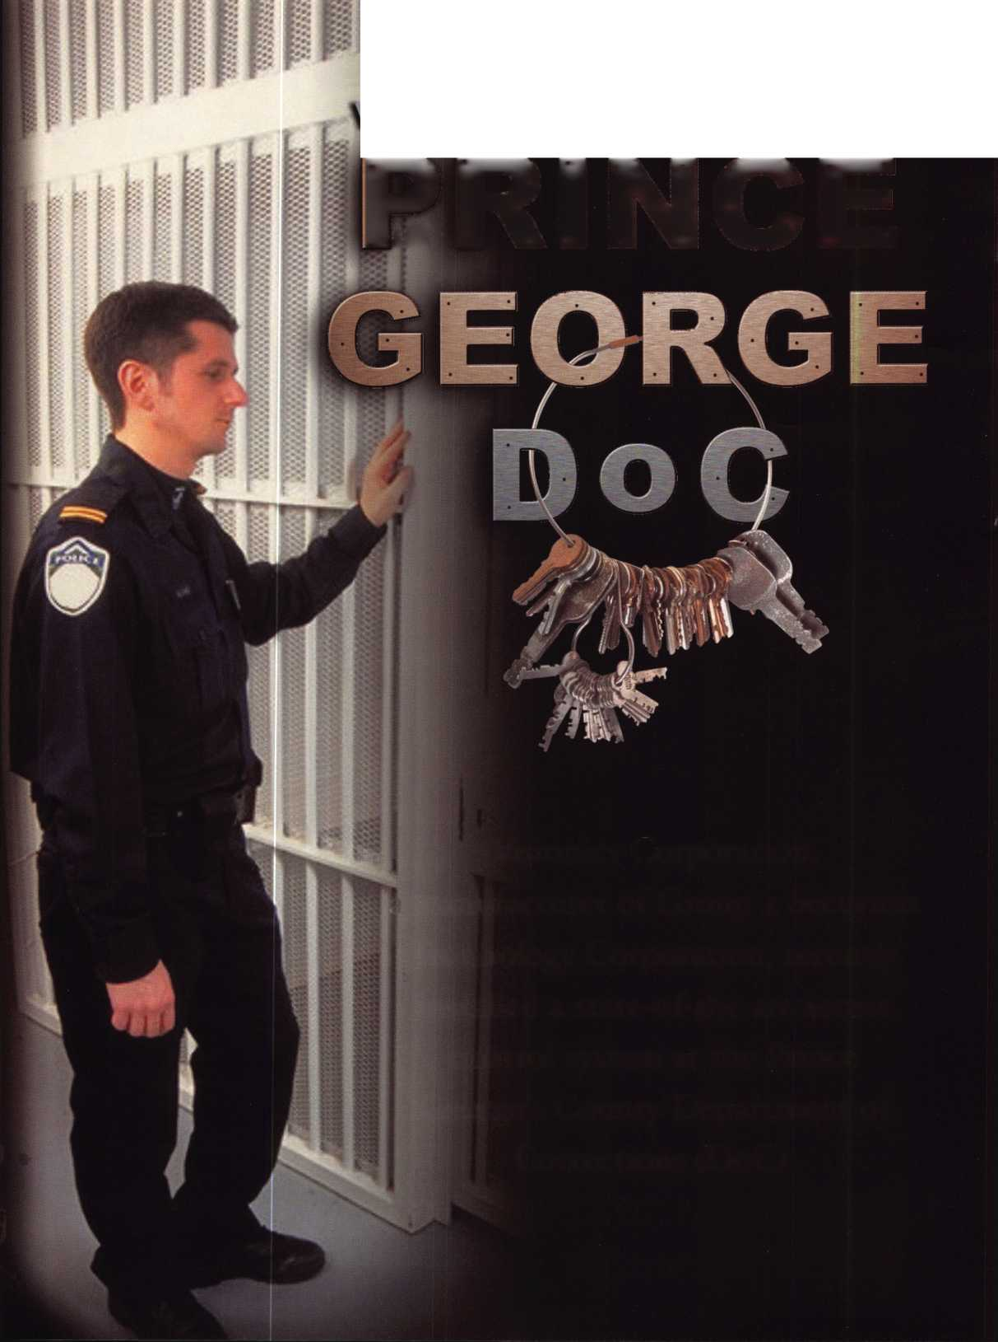

The access control system uses Facelt technology to verify the identities of DoC employees and tracks their movement throughout the facility Prince George’s County Department of Corrections (DoC) is considered one of the most presti­gious correctional facilities in the U.S.

Long recognized for its professionalism, Prince George DoC has received much fanfare for its “direct supervision” model, an unconventional approach to inmate management that has yielded no security breaches since 1989. Also commended for creating an automated booking system, the DoC has received numerous high-level visitors such as former presi­dent Clinton, Department of Defense (DoD) officials and international government envoys interested in the institu­tion’s innovative practices.

The Prince George DoC’s security need arose from an inability to quickly locate staff in the event of a facility-wide emergency “We couldn’t tell which employees were in the building at any given time,” said Lieutenant Colonel Carl Crumbacker, Chief of Security at the Prince George Department of Corrections. “We didn’t have any existing problems that warranted a security upgrade. It was more a want of staying ahead of the game.” The equipment chosen to meet the DoC’s security need were Group 4’s AMAG access control system and Visionics’s facial recognition tech­nology, Facelt®. The AMAG system provides real-time card­holder accountability while the Facelt® system verifies iden­tities using the latest in biometric identification technology. Together, the technologies enhance DoC security by provid­ing material (i.e., smart cards) and biometric (i.e., facial pat­terns) criteria for admitting employees.

“Employees are now identified and tracked throughout the facility from the time they arrive to when they leave. There is now complete accountability in the system,” remarked Lt. Col. Crumbacker. Dr. Joseph J. Atick, chairman and CEO of Visionics said, “The use of Facelr technology in conjunction with a smart card adds a significant layer of security to tra­ditional access control. The Group 4 AMAG installation in Prince George is a great example of the wide range of sce­narios in which Facelt" technology can be applied.” “Group 4 is honored to have had our AMAG product chosen to serve the security needs at the Prince George institution,” said Robert Sawyer, President of Group 4 Securitas Technology Corporation. “We believe the depth of experi­ence we have had with other government applications, like the Pentagon, will ensure the DoC has the best possible technology at their disposal when using the combined Group 4/Visionics access control system.” About Group 4 Securitas Technology Corporation

Group 4 Securitas Technology has been at the leading edge of access control technology for over 30 years. Group 4 AMAG access control systems are providing companies worldwide with scalable solutions that integrate the latest technologies. Group 4 Securitas Technology is a subsidiary of $3 billion Group 4 Falck, the second largest Security Company in the world with 115,000 employees operating in over 50 countries.

For more information about Group 4, please visit their web­site at [www.amagaccess.com](http://www.amagaccess.com) or call the media contacts listed above. For additional information about Visionics, please visit their website at [www.visionics.com](http://www.visionics.com). Q

Congratulations to William Pettit of Ocoee, FL. He is this

year’s winner of the ITL 950 Key Machine (shown here)

The drawing is held each year from a pool of members

who pay their membership dues by Dec. 31

Keynotes • February 2002

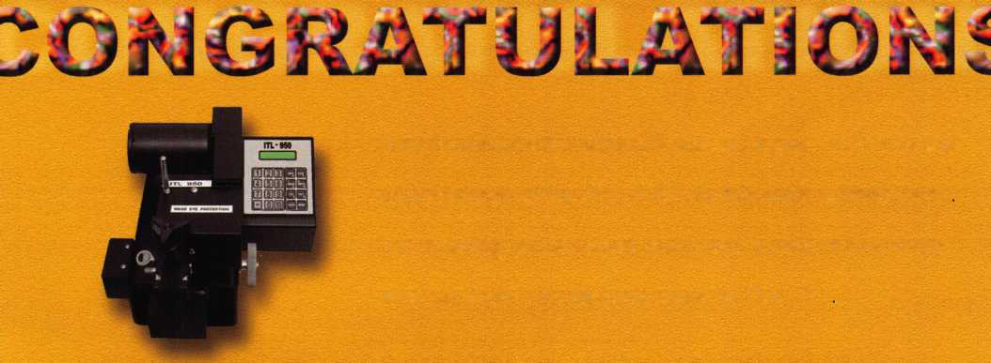

**ALOA Scholarship Foundation, Inc.  
Scholarship Application**

3003 Live Oak Street; Dallas TX 75204  
(214) 827-1701, (800) 532-2562

Please print or type **Name**

**Home Address . Home Phone**

**Present Employer .**

**Work Address**

**Work Phone**

**Position**

**PRP/STPRP Level . City**

ALOA/SAVTA#.

**State Zip _**

**Dob**

**Educational Level .**

**{years) Degree, If Any_**

**Supervisor’s Full Name . City**

**State**

**Zip.**

**Fax**

**Full Time .**

**Part Time _**

**Take Home Pay_**

**Length Of Time In Locksmithing**

**Marital Status Number Of Dependents Classes Desired**

**Membership In Trade Associations (List By Name) .**

**Household Annual Gross Income .**

**Date Of Classes**

**Organization Sponsoring Classes: ALOA.**

SAVTA

**Other**

**Location**

Applications will be reviewed by the ASF Selection Committee on an objective and nondiscriminatory basis. All materials and information pertaining to the applicant’s financial status and background shall be held in strict confidence by the Selection Committee.

ALOA Scholarships are granted to selected individuals desirous of entering the locksmithing field or to selected individuals already in the locksmithing field who wish to improve their professional skills through education.

Applications for classes must be received 60 days prior to the date of the class, and will be reviewed as they are submitted. Scholarships for classes at the ALOA or SAVTA convention will be awarded each year at the ALOA Scholarship Foundation meeting preceding the convention and must be received by March 1 each year.

Please attach to this form a letter stating your reason for applying for a scholarship, what you plan to do with the knowledge you obtain and any other information you feel may be helpful to the scholarship board in making its decision. In addition, attach three letters of reference from individuals who have personal knowledge of your background and character. The letters should contain their names, addresses and phone numbers. It would be helpful if at least one of these references is an ALOA or SAVTA member. All scholarship recipients will be required to provide a 3” x 5” photograph of themselves.

**Application Checklist**

Only complete applications will be considered for scholarships. An application is considered incomplete unless ALL of the above requested information is received before the deadline: 60 days prior to the classes desired, March 1 for ALOA/SAVTA convention classes. Please send this application after checking off each of the below.

* I have filled in each blank on this form.

O I have written and enclosed a letter explaining my reason for applying.

* I have enclosed three letters of reference.
* I am submitting this in time to be received 60 days prior to the date of a class or by February 1 for ALOA/SAVTA convention classes.

O I have enclosed a 3” x 5” photograph.

**Certification Of Applicant**

I certify that the information contained herein, and all supplemental forms are complete and correct to the best of my knowledge. I further certify that if I am selected as a scholarship recipient I will use the knowledge gained for the improvement, development and advancement of the lock­smithing profession. Also, if asked by an authorized ASF official, I agree to give proof of the information that I have given on this application. I also understand that this proof my include copies of my previous year’s Federal Tax Return. I also understand that if no proof is given when request­ed, I may not receive consideration for an ALOA Scholarship Award. I understand that this application is valid only for the event/class specified.

Signature.

Date.

Please send all completed applications to:

ALOA Scholarship Foundation, Inc. • 3003 Live Oak Street • Dallas, TX 75204

Revised 12/01



**April 8-13 John Ascuaga's Nugget Resort • Reno, Nevada**

reno, nevada



2^2



Licensing

Is What the Future Needs...

Karl Kretsch

So another Tri-Regional is under our belts- what a hard  
working committee! The success of the show owes much to  
the monthly meetings we endured in Woodburn. In the days  
that preceded the show I sometimes worried that the rag tag  
group of volunteers wouldn’t put it together. By Saturday  
evening, as I sat on my perch at the banquet head table  
and listened to the introductions of the ALOA  
officers present, that worry was trans-

formed to a feeling of accomplish-  
ment. We had pulled it off. The  
feedback we were receiving was  
pleasantly positive. The instruc-  
tors were well taken care of and  
rather appreciative. The trade  
show exhibitors were satisfied,  
even the ones who endured  
thousands of miles of air trav-  
el to attend. As I sat enjoying  
my second helping of  
Chocolate Mousse, I fantasized  
that now we could all relax.

After a round of ‘pat on the backs’  
and ‘job well done’s, we could return  
to our families and our shops and for-

get all about the betterment of locksmiths.

I looked around the room, and I could swear I saw that same look of serenity on the faces of the other lock­smiths who had been on the committee. Then Randy Simpson, the president of the Associated Locksmiths of America and the night’s Keynote speaker took the Podium...

At first his words supported my position, which you must remember was rather laid back and relaxed, after all that mousse. He too offered us all a warm pat on the back. He applauded our professionalism and attention to detail. He hailed our commitment to provide classes of the caliber we did. Then he thanked us for the opportunity to hold A.C.E. classes and boasted of their successes the in the year 2001. Record numbers of classes were being held. Not just in



Oregon, but all over the country. Like the good father I  
always imagined a President would be, I was positive his  
speech would be the lullaby that would send us all to our  
post-feast slumber. Then something happened. Just as I  
thought I might get used to the post conference lull I had  
promised myself, our president changed his mind. What  
began as a reassuring bedtime story soon  
turned into something drastically differ-

ent. Apparently there was no time for  
quiet rest and self-congratulation.  
He made that loud and clear when  
he mentioned one little nine-let-  
ter word: licensing.

He began to tell us a story  
about the state of Texas, the  
home of ALOA. Not long ago  
a nightmare visited the lock-  
smiths there. The politicians  
were going to pass a law that  
would have a great impact on the  
livelihood of present and future  
locksmiths. It was written to give  
alarm installers and other low voltage

professionals, sole dominion over any  
security work that involved electricity of any  
kind. Its passage would certainly be bad news for lock-  
smiths in Texas. Lock work and access control is increasing-  
ly electronic. I have hung out with enough locksmiths to  
know that we all agree the future is in electrified hardware.  
What were the men and women of Texas going to do ten or  
fifteen years from now if such a law passed? His story had a  
happy but frantic ending for locksmiths. In the twelfth hour,  
our hero, the Governor, vetoed the bill and fort the time  
being the future of the profession was spared. His story con-  
cluded with the chilly promise that this bill would return. It  
might wear different clothes, or it might speak with a some-  
what different accent, but it would return.  
He suggested that Texas locksmiths would be ready.



Keynotes • February 2002

I have to admit that it wasn’t the story alone that was going  
to get me up from my resting-place. But like the alarm clock  
that slowly gets louder the longer you ignore it, the point of  
his story began to wake me up. I know full well what licens-  
ing has done to the locksmiths in my state. The Oregon  
Revised Statutes has already put most electronic access con-  
trol into the hands of the alarm industry. If it weren’t for the  
advent of stand-alone hard-  
ware we would have no hand

in twenty-first century access  
control.

Sitting in that room looking  
at all those locksmiths from  
Oregon, his point seemed  
moot. We had already lost  
that battle and I was not  
going to be the fool who  
raised his hand, so he could  
stand up and tell the teacher.

I contented myself to finish  
my chocolate mousse and  
plan my self-imposed exile.

But I heeded his words and  
promised my fellow lock-  
smiths that I would be by  
their sides if the tow truck  
driver lobby ever got too pow-  
erful. I would not let us lose  
the right to open cars. I also  
made up my mind to join the  
Legislative Action Network

with ALOA. At least they would warn me about the next law.

1

n

All in all his speech was very arousing. If this association were to heed his warning, there would be lots of work to do and much vigilance needed. But I had been promising myself a little playtime and there were things do around the house. We could always leave this up to the next bunch of guys who call themselves the officers. We heard the call Mr. President, but are hands are tied legally and we simply need to find time to schedule our response. Those were all excuses that seemed good enough to me as I started my first week of real work. But I promise you I was listening.

About the third day back to work I had to visit a local Town Hall/Police station that was having some troubles with a new ‘card lock’ system that was installed, a couple of weeks prior. One of the companies we own is an alarm company. Because of the access to low voltage licensees, I am able to do a lot of this work. I had been one of the competing bids on this proj­ect. I am told my bid was about twenty percent higher than the low man. After visiting the location now, I can see why.

On the telephone, the Chief related to me that some of the  
electric strikes were not working properly. In one case peo-  
ple were using any variety of instruments to pull the latch  
back on the lock. When I got to the location to start ana-  
lyzing the work, I heard that familiar nine-letter ‘alarm  
clock’ word I had heard the night that I ate too much  
mousse: “Don’t you guys need licenses to do this?” were the

chief’s first words.

I sort of chuckled and began  
to inspect each of the 15  
strikes installed through out  
the police station and town  
hall. Ten of the strikes were  
questionable, and eight of  
those had some functional  
problem that made them  
inoperable. What I began to  
think of as I wrote my notes  
was the complete irony of  
the situation. Here I was the  
unlicensed, analyzing and  
critiquing the work of a  
company that was licensed  
to perform the work. In an  
attempt to come up with  
some kind of justification  
for such work, I surmised  
that a licensed professional  
had simply taken the cheap-  
est strike from his glass door  
catalog and multiplied times

fifteen. The fact that some of the latches in question did not  
lock or that some of them were exit devices apparently was  
not taken into account. At one particular door I actually  
searched the area for remnants of some poor alarm installers  
hair. Convinced he must have pulled most of it out, as he  
attempted to install his hardware.

Maybe I was guilty of pushing the snooze button on the  
President’s wake up call. As I said I was going to rest. After  
all I worked with an alarm company. Maybe we were expen-  
sive. We were committed to work better than this. Like the  
man with the down sleeping bag who lets someone else stoke  
the morning campfire, maybe I had considered myself to  
warm and cozy to get up. Discussing things with the Police  
department that afternoon, I finally realized that our  
President was right. It is time to wake up to the idea of  
licensing. My page of information on the Police chief’s desk  
was a clear indication of the effects of the alarm industry  
control over twenty-first century security

Present regulations in Oregon may ensure that there will be

The future is not out of reach.  
A secure place in it for  
our profession is not either.

Keynotes • February 2002



no electrical mishaps when installing low voltage access con­trol systems. However it places no value on the quality of the security, or on the importance of life safety and egress cer­tainty When situations like this occur it becomes clear to me that licensing has strangely given the responsibility of securing assets to an industry that until only recently was solely concerned with monitoring assets. They (the alarm industry) just don’t understand all that is necessary in secur­ing a building. That has always been the role of locksmiths. So the reality of what our President said on that night final­ly stirred me. Not only has this licensing impacted our per­ceived future, it has drastically effected the quality of the security that the future has to offer.

Though it took a few days and a police department’s misery to understand this. I now can truly say the neatest thing I picked up in Portland at the Tri-Regional Conference was that banquet speech. Neater than passing my PRP, neater than the denim shirt from Clark Security, neater than finally meeting some of the guys who carry-on on clear star, was the wake up call that came after all the mousse. I am now awake to the idea that Oregon needs to think about licensing.

Existing regulations have hurt us and we have to become proactive in securing a role in twenty-first century security.

I think more importantly though we owe it to the consumer to assert ourselves. Life safety and security have been our domain since fires were lit in front of caves. We know access control better than alarm installers know ohm’s law. To shift that control to an industry simply because it understands the wiring involved does not protect the interests of the con­sumer. Access control hardware is expensive to purchase and maintain. Consumers who make the decision to purchase this expensive hardware should have some assurance that it will be installed properly. Existing limited energy licenses do not provide that assurance.

To every locksmith who reads this, I hope I have somehow stirred you. The future is not out of reach. A secure place in it for our profession is not either. Q

**Associated  
;|X| Locksmiths**

*"Wor* 0F

America

*at* [www.afoa](http://www.afoa).

NUMBER

(800)532-'AXO'A

'Wow you can show off your ‘ALO'A membership in styfe. “Regufar members andLife ‘Members can simpfy gfue the membership card onto the marbfe (as shown). Don’t miss out on this affordable, official ‘AXO'A dispCay. T’he cfassy sfate-cofored marbCe comes with feft padding for your desktop or van. It can be easdy mounted to show off your AXOApride in your office/shop! T’he cost for you to dispfay your professionabpride, you ask? Onby $20!

Keynotes • February 2002

**3**

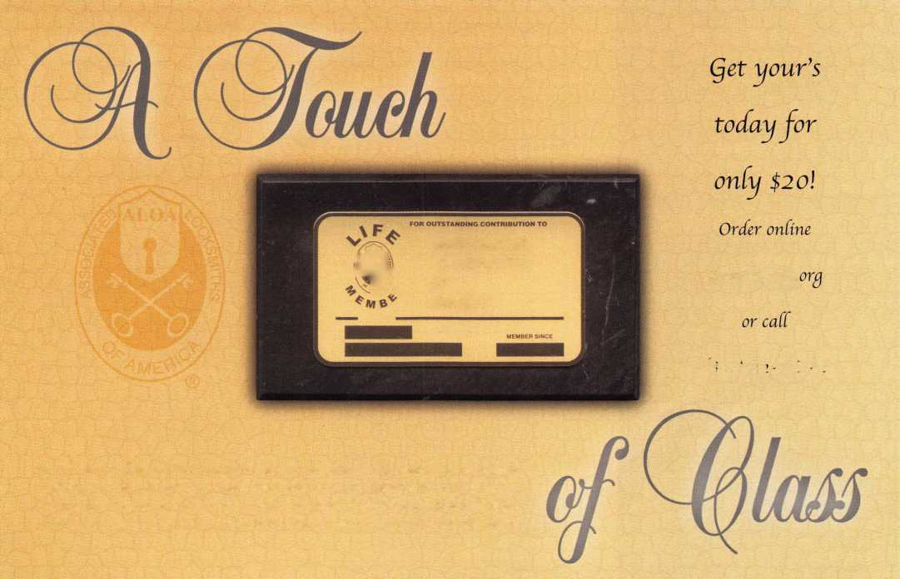

BOARD

nominations

**What ALOA Board Positions Are Open and Where Am I Qualified to Run?**

There are currently seven regional directors positions open for election in addition to the position of Secretary. ALOA members now elect the directors from their own regions. Only ALOA members from a region are eligible to run for the open posi- tion(s) in that region. And only mem­bers from th§ nominee's region will receive a ballot to vote for that can­didate. Members from any region are eligible to run for the Secretary position. You must have been an ALOA member for at least three years to run.

The following vacancies will exist for the election to be held before the ALOA 2002 Convention.

**Northeast three directors**

**South Central one director**

**Northwest one director**

**Asian one director**

**European one director**

**Secretary**

If you have any questions, please contact Charles Gibson at (800) 532-2562 or email [charlie@aloa.org](mailto:charlie@aloa.org).

On this page you will find the required nomination petition and on the following page, the nomina­tion form.

The following is the number of signatures required for each Board position:

**Secretary 25**

**Northeast 22**

**South Central 7**

Associated Locksmiths of America, Inc.

Board of Directors Nomination Petition

Please print legibly or type. This form can be reproduced if needed.

I, the undersigned, request that be placed on

(name of nominee and member number)

the ballot for for the election to be held at

(position for which individual is being nominated)

the special meeting of ALOA members to be held in 2002 or any adjournment thereof. I am eligible to vote in the region.







PRINTED NAME



PRINTED NAME



PRINTED NAME



PRINTED NAME



PRINTED NAME



PRINTED NAME



PRINTED NAME



PRINTED NAME



PRINTED NAME



PRINTED NAME

11

PRINTED NAME

12

PRINTED NAME



PRINTED NAME



PRINTED NAME



PRINTED NAME



PRINTED NAME



PRINTED NAME



PRINTED NAME



PRINTED NAME



PRINTED NAME

21

PRINTED NAME

22

PRINTED NAME

MEMBER #

MEMBER #

MEMBER #

MEMBER #

MEMBER #

MEMBER #

MEMBER #

MEMBER #

MEMBER #

MEMBER #

MEMBER #

MEMBER #

MEMBER #

MEMBER #

MEMBER #

MEMBER #

MEMBER #

MEMBER #

MEMBER #

MEMBER #

MEMBER #

MEMBER #

SIGNATURE

SIGNATURE

SIGNATURE

SIGNATURE

SIGNATURE

SIGNATURE

SIGNATURE

SIGNATURE

SIGNATURE

SIGNATURE

SIGNATURE

SIGNATURE

SIGNATURE

SIGNATURE

SIGNATURE

SIGNATURE

SIGNATURE

SIGNATURE

SIGNATURE

SIGNATURE

SIGNATURE

SIGNATURE

**Northwest 4**

**Asian 3**

**European 4**



PRINTED NAME MEMBER # SIGNATURE



PRINTED NAME MEMBER # SIGNATURE



PRINTED NAME

MEMBER #

SIGNATURE

YOUR COMMITMENT TO ALOA BOARD SERVICE

(Please read carefully and sign where indicated.)

The responsibilities of an ALOA board member include contributing a moderate amount of personal time, and a significant degree of professional guidance and expertise to the organization.

You will be expected to come to board meetings and the annual membership meeting. You will need to be prepared to sensibly discuss matters of great importance to your profession and participate in setting policy as part of a governing body. Your course of action during your tenure on the ALOA board should be guided by fair minded, constructive goals pertaining to matters of consequence for ALOA and for the industry. Your contributions are expected to benefit ALOA as a whole, taking individual member rights and concerns into account, but free of the taint of partisan politics or personal gain.

On a practical note: ALOA board members are expected to behave and dress professionally at all times, especially when actively representing the association. ALOA board members are required to participate in two board meetings per year, of three or four days in length, one each fall and spring. Board members are also asked to attend the annual con­vention and are required to attend the annual membership meeting. Board members may also be asked on a voluntary basis, to represent ALOA at related local, state or regional functions, including serving in the ALOA Booth and otherwise promoting ALOA. When travel is required for a board member, expenses covered by ALOA include lodging, travel and a reasonable **per diem.** The Board has stipulated that assigned travel will be reimbursed at the lesser of the 30-day advance tourist class airfare in effect at the time of travel or the current per-mile rate for travel by personal automobile. Spouse expenses, including extra room charges, etc., are the individual's responsibility.

• • •

I have read and understand the above responsibilities of an ALOA board member, and agree to commit my time and energies as needed. I certify all of the information contained on this form and supporting documentation to be true and complete.

I can be contacted with questions at:

Address Phone #

Signed:

Date

Please attach a recent photograph of yourself and retain a copy of this profile for your own files. This profile and all supporting documentation should be submitted no later than April 1, 2001:

Mail to:

Nominee Profile

Secretary of the Board of Directors  
Associated Locksmiths of America  
3003 Live Oak Street  
Dallas, TX 75204-8186

Rev. 12/01

EMPLOYMENT

EXPERIENCED LOCKSMITH WANTED

Do you love the trade of Locksmithing? Are you hard working and self motivated? If you are, we are the company for you. A growing locksmith company in California is looking for techs that work with automotive, commerical and residential. Looking for techs that has a min. of 2 yrs. of exp. We offer

full benefit package and payed vacation. Trucks and tools are provided. Clean driving record. High salary is payed to top technicians. Take pride in where you work and come aboard on a winning team. Locksmith Central • 15934 Hesperian Blvd. Suite 264 • San Lorenzo, Ca 94580 Voice: 1.888.81.LOCKS

LOCKMASTERS INC.

of Nicholasville, KY, a leader in automotive and locksmith tools is looking a for self-motivated person to fill our growing and fast paced automotive and locksmith tool inside sales staff. Must be people oriented, a self starter, have overall understanding of locksmith market, and be willing to relocate to Nicholasville/ Lexington Kentucky. Background in automotive and general locksmithing a plus. Send resume to Lockmasters Inc.,

5085 Danville Rd., Nicholasville, KY 40356.

SECURITY TECHNICIANS NEEDED

Looking for experienced, motivated, hard working technicians and team players. Great income potential. We offer paid holidays, vacation, and medical. Don't delay, fax your resume today. Liberty Lock and Safe, FAX 702/876-5470 or [www.libertylock.com](http://www.libertylock.com).

WANTED: EXPERIENCED PROFESSIONALS

Ready to take a step in the right direction? If you are an experi­enced security professional with strong sales skills, come join our team. We are a rapidly expanding 35-year-old business in the beautiful Pacific Northwest. The ideal candidate would have a strong backgroung in commercial security and door hardware or electronic access control, CCTV and alarms. We will train the right candidate. We offer 401 (k), paid vacation, medical, new uniforms and a work environment that encourages growth and

WANTED

Experienced Service Technician sought for established company in central Illinois. Must be neat in appearance with good work habits. Good driving record a must. Our company offers a good salary with an excellent benefits package. Many extras. Send resume or contact: Denny, Dave and Harry Locksmiths,

Inc. 116 E. University Ave. • Champaign, IL 61820 Phone: (217) 352-5034 • Fax: (217) 352-3505

LOCKSMITH WANTED

Busy shop in Woburn, MA, has immediate opening for a self- motivated, reliable locksmith. Large customer databases for automotive, AAA, commercial and residential accounts. Applicant with own van and tools is guaranteed 50 percent commission. If no van or tools, we can supply. A great opportu­nity for the right individual. All inquiries are kept strictly confi­dential. Send resume to: Locks and Keys Inc. • P.O. Box 222 Woburn, MA01801 • e-mail: [jobs@locks-keys.com](mailto:jobs@locks-keys.com) Phone: (781) 933-9999.

SECURITY TECHNICIAN NEEDED

Looking for experienced, motivated technician. We offer good income, 401 (k), medical plans. Fax us your resume (781) 321-2422.

at

Classified Advertising Policy

Classified advertising space is provided free of charge to ALOA members, and fora fee of $.60 per word, $15 minimum for non-members. Classified ads may be used to advertise  
used merchandise and overstocked items for sale, "wanted to buy" items, business opportunities, employment opportunities/positions wanted and the like. Members or non-members wishing  
to advertise services or new merchandise for sale may purchase a "Commercial Classified Ad," for a fee of $1.30 per word, with a minimum of $40. Each ad will run for two issues. For blind  
boxes there is a $5 charge to members and non-members. All ads must be submitted in writing to the ALOA office by the fifteenth of the month, two months prior to issue date. Send to  
Keynotes Classifieds, 3003 Live Oak St., Dallas TX 75204-6186. ALOA reserves the right to refuse any classified advertisement that it deems inappropriate according to the stated purpose

of the classified advertising section.

Keynotes • February 2002



rewards those with dedication! Contact Paul Brandon at The Lock Shop toll free at 866/LOCKSHOP, or on the web at [www.lockguys.com](http://www.lockguys.com).

AUTO EXPERT WANTED

Looking for experienced car/auto locksmith. Great pay, paid vacation, bonus and education. Call 281/830-9441.

WORK WANTED

SECURITY PRO FOR HIRE

CML, CPS seeks a challenging and personally rewarding position as a Locksmith, at the supervisor or management level. Would prefer institution or college in the Midwest or central United States, however all locations would be considered. 30+ years in the field and well versed in all aspects of sales, training and management. Please respond to the editor at ALOA,

(800) 532-2562, ext. 19.

BUSINESS FOR SALE

BUSINESS FOR SALE

Well established lock and safe company (19 years) with many long-time account customers. Three fully equipped vans, two pick-ups, shop equipment, etc. Located in super-fast growing area in Maryland.

Gross $500K with loads of growth potential. Serious inquiries call Dave @ (301) 748-1885.

BUSINESS FOR SALE

Located in Hayward, California. Company been around for 6 years. Have a large number of commerical Accounts. In this territory we have a contract with AAA. Heavy commerical and automotive work done. Looking for a person that well trained in Locksmithing to take over operations. Meaning Commerical, Automotive, Residential. Gross Sales per year are $400,000+ Call For Details. Ask for Robert: (888) 81-LOCKS

BUSINESS FOR SALE

Well-established lock and safe business for sale in the Midwest. Commercial property is located on the corner of a very busy intersection, has a two-bed­room apartment above shop and a full-service 7-car detached garage in rear. Property appraised for $95,000. Sale includes property, two fully equipped service vans, all fixtures, equipment, and inventory. Gross annual sales of $220,000. Employees will remain; owner available for transition. Owner assisted financing possible. Call 815/654-0882.

WANTED TO BUY/SELL

FOR SALE

Used Woodword Stairclimber - great condition - $1500. Contact Wayne Parker at A-l Key and Safe, Inc. (727) 525-5513.

FOR SALE

HPC 1200CM Blitz code machine. Over 100 cards, two cutter wheels, manual and card book. Approximately five years old. Works great.

$1200 plus shipping/insurance. Call John at 203/397-3093, or e-mail at [amitylock@snet.net](mailto:amitylock@snet.net).

Locksmith Training

Sponsored by Fox Valley Technical College • I 825 N. Bluemound Dr. • Appleton, Wl 54912-2277

6-Day Program • Career Change in One Week • March 18-23, 2002

This is a basic locksmithing training course sponsored by FVTC’s Security and Crime Prevention  
Department and conducted by ALOA ACE instructors. Designed for the locksmith shop owner  
who would like to provide entry-level training for new apprentice locksmiths as well as those who

would like to receive professional training that will enable employment with a professional locksmith. The course will allow the student  
to gain enough knowledge to make them a starting apprentice in an existing shop. Job placement locations will be made available at the  
time of the class.

To maintain quality the course enrollment will be capped at 12 students. Enroll early!

Curriculum includes:

Key Blank Identification and Duplication Lockset Servicing, Functions, Finishes

Key Codes and Code Equipment Life Safety Codes

Basic Master Keying Lock Pick Opening Techniques

All tools and equipment will be made available for use during training.

Class Hours: 8:30 am to 5:00 pm every day Class Attire: Shop clothes Course Tuition: $995.00

Pin and Disc Cylinder Servicing Door Closers

Key Impressioning Lockset Installation

Lock By-Pass Techniques Cabinet, Furniture Mailbox Locks

Exit Hardware

Course Enrollment: See Linda Buck in the Criminal Justice Center

or call 920-735-2406

Note: Enrollment deadline is Friday, February 15, 2002



Keynotes • February 2002



A & B Safe Corporation

Phone: 800-253-1267 Fax: 856-863-1208 [www.a-bsafecorp.com](http://www.a-bsafecorp.com)

ADI Inc.

Phone: 516-692-1000 Fax: 516-692-3457

Abloy Door Security

Phone: 514-335-9500 Fax: 514-335-0430 [www.abloy.com](http://www.abloy.com)

Accredited Lock Supply Co

Phone: 201-865-5015 Fax: 201-865-0030 [www.acclock.com](http://www.acclock.com)

Ace Lock & Security Supply

Phone: 908-688-7666 Fax: 908-688-2442 [www.acelock.com](http://www.acelock.com)

Action Hardware Inc.

Phone: 800-662-6695 Fax: 800-930-2329

Action Hardware

Phone: 800-662-6695 Fax: 800-930-2329

Adams Rite Mfg Company

Phone: 800-872-3267 Fax: 800-232-7329 [www.adamsrite.com](http://www.adamsrite.com)

Adesco Safe Mfg. Company

Phone: 800-821-6803 Fax: 562-408-6427 [www.adesco.com](http://www.adesco.com)

Adrian Steel Company

Phone: 800-677-2726 Fax: 517-265-5834 [www.adriansteel.com](http://www.adriansteel.com)

Alarm Lock Systems Inc.

Phone: 800-252-5625 Fax: 516-789-3383 [www.alarmlock.com](http://www.alarmlock.com)

Allstate Insurance Company

Phone: 847-402-8196 Fax: 847-326-7509 [www.allstate.com](http://www.allstate.com)

American Lock Company

Phone: 708-534-2000 Fax: 708-534-0531

American Security Products

Phone: 909-685-9680X1083 Fax: 909-685-9685 [www.amsecusa.com](http://www.amsecusa.com)

£

Andrews Wholesale Lock Supply

Phone: 717-272-7422 Fax: 717-274-8659

BWD Automotive

Phone: 334-872-6524 Fax: 334-874-601 1 [www.bwdautomotive.com](http://www.bwdautomotive.com)

Baldwin Hardware

Phone: 610-796-4012 Fax: 610-796-4493

Boyle & Chase Inc.

Phone: 800-325-2530 Fax: 800-205-3500 [www.boyleandchase.com](http://www.boyleandchase.com)

Buddy Products

Phone: 800-886-8688 Fax: 312-733-8356

COMPX Security Products

Phone: 864-297-6655 Fax: 864-297-9987 [www.nclnet.com](http://www.nclnet.com)

Clark Security Products

Phone: 800-854-2088 Fax: 619-974-5284

Cook's Building Specialties

Phone: 505-883-5701 Fax: 505-883-5704

Curtis Industries,

A Barnes Distributor

Phone: 800-555-5397 Fax: 800-867-6020 [www.curtisindustries.com](http://www.curtisindustries.com)

DETEX Corporation

Phone: 800-729-3839 Fax: 830-620-671 1

DORMA Architectural Hardware

Phone: 717-336-3881 Fax: 717-336-3500 [www.dorma-usa.com](http://www.dorma-usa.com)

DSC Group Of Companies

Phone: 905-760-3000 Fax: 905-760-3040

Dire's Lock & Key Company

Phone: 303-294-0176 Fax: 303-294-0198

Direct Security Supply, Inc.

Phone800-252-5757 Fax: 800-452-8600

Don-Jo Manufacturing, Inc.

Phone: 978-422-3213 Fax: 978-422-3467 [www.don-jo.com](http://www.don-jo.com)

Door Controls International

Phone: 800-742-3634 Fax: 800-742-0410 [www.doorcontrols.com](http://www.doorcontrols.com)

Doyle Security Products

Phone: 800-333-6953 Fax: 612-521-0166 [www.doylesecurity.com](http://www.doylesecurity.com)

Dugmore and Duncan, Inc.

Phone: 888-384-6673 Fax: 888-329-3846

E. L. Reinhardt Co., Inc.

Phone: 800-328-131 1 Fax: 612-481-0166 [www.elreinhardt.com](http://www.elreinhardt.com)

ESP Lock Products Inc.

Phone: 978-537-6121 Fax: 978-534-9109

Emergency Road Service Inc.

Phone: 888-839-5386 Fax: 678-277-8105

Ewert Wholesale Hardware

Phone: 800-451-0200 Fax: 708-597-0881

Fairway Supply, Inc.

Phone: 214-350-0021 Fax: 214-352-4299 [www.fairwaysupply.com](http://www.fairwaysupply.com)

Foley-Belsaw Company

Phone: 800-821-3452 Fax: 816-483-5010 [www.belsaw.com](http://www.belsaw.com)

Fried Brothers Inc.

Phone: 800-523-2924 Fax: 215-592-1255

H L Flake Co.

Phone: 800-231-4105

H.S. & S. Wholesale Distrib.

Phone: 313-342-6777 Fax: 313-342-7580

HES, Inc.

Phone: 623-582-4626 Fax: 623-582-4641 [www.hesinnovations.com](http://www.hesinnovations.com)

HPC, Inc.

Phone: 847-671-6280 Fax: 847-671-6343

[www.hpcworld.com](http://www.hpcworld.com)

Hans Johnsen Company

Phone: 214-879-1550 Fax: 214-879-1530

Hardware Agencies, Ltd.

Phone: 416-462-1921

Hongtai Lock Co Ltd.

Phone: 137-238-1414 Fax: 208-793-3856

Howard Keys

Phone: 704-509-4944 Fax: 704-509-6248 [www.howardkeys.com](http://www.howardkeys.com)

IDN Incorporated

Phone: 817-421-5470 Fax: 817-421-5468

INTELLIKEY Corp.

Phone: 800-226-0703 Fax: 321-724-0811 www. i n tel I i key. com

llco Unican

Phone: 252-446-3321 Fax: 252-446-4702 [www.kaba-ilco.com](http://www.kaba-ilco.com)

Intermountain Lock & Supply

Phone: 800-453-5386 Fax: 801-485-7205 [www.intermountainlock.com](http://www.intermountainlock.com)

Jensen Tools Inc.

Phone: 602-453-3169 Fax: 602-438-1690

Jet Hardware Mfg., Co.

Phone: 718-257-9600 Fax: 718-257-0973

Jo Van Distributors

Phone: 416-752-7249 Fax: 416-752-3845

KABA High Security Locks

Phone: 860-621-3601 Fax: 860-621-9727 [www.kabausa.com](http://www.kabausa.com)

KEY-BAK/West Coast Chain Mfg.

Phone: 909-923-7800 Fax: 909-923-0024 [www.keybak.com](http://www.keybak.com)

**2**

Keynotes • February 2002



Knaack Manufacturing Co.

Phone: 800-456-7865 Fax: 815-459-9097 [www.weatherguard.com](http://www.weatherguard.com)

LAB Security

Phone: 800-243-8242 Fax: 860-583-7838

LCN Closers/Div of Ingersoll

Phone: 815-875-3311 Fax: 815-879-1497 [www.lcnclosers.com](http://www.lcnclosers.com)

La Gard Inc.

Phone: 310-325-5670 Fax: 310-325-5615 [www.lagard.com](http://www.lagard.com)

Lockmasters, Inc.

Phone: 859-885-6041 Fax: 859-885-7093 [www.lockmasters.com](http://www.lockmasters.com)

Locks Company

Phone: 800-288-0801 Fax: 305-949-3619

Locksmith Ledger International

Phone: 770-886-0800 Fax: 770-889-7703 lledger.com

Lucky Line Products, Inc.

Phone: 858-549-6699 Fax: 858-549-3241

M. Zion Company

Phone: 212-349-8677 Fax: 212-964-0495

M.A.G. Security

Phone: 714-891-5100 Fax: 714-892-6845 [www.magsecurity.com](http://www.magsecurity.com)

MARKS, U.S.A.

Phone: 516-225-5400 Fax: 516-225-6136 [www.marksusa.com](http://www.marksusa.com)

Marray Enterprises

Phone: 408-970-0213 Fax: 408-970-8767

MCS Communication Systems

Phone: 514-444-2040 Fax: 514-444-2029 [www.mcscommunication.com](http://www.mcscommunication.com)

MUL-T-LOCK USA, Inc.

Phone: 800-562-3511 Fax: 973-778-4007 [www.mul-t-lock.com](http://www.mul-t-lock.com)

Massglass & Door Service

Phone: 888-742-8837 Fax: 818-991-5742 [www.massglass.com](http://www.massglass.com)

Master Lock Company

Phone: 414-444-2800 Fax: 414-444-0322 [www.masterlock.com](http://www.masterlock.com)

McDonald Dash Locksmith Supply

Phone: 800-238-7541 Fax: 901-366-0005 [www.mcdonalddash.com](http://www.mcdonalddash.com)

McManus Locksmith Supply, Inc.

Phone: 704-333-9112 Fax: 704-332-8664

Medeco Security Locks

Phone: 540-380-5000 Fax: 540-380-5010 [www.medeco.com](http://www.medeco.com)

Meilink Safe Company

Phone: 800-634-5465 Fax: 800-896-6606

[www.fireking.com/products_Meilink/mk](http://www.fireking.com/products_Meilink/mk)

Monaco Lock Co.

Phone: 800-526-6094 Fax: 800-845-5625 [www.monacolock.com](http://www.monacolock.com)

MMD, Inc.

Phone: 865-428-361 1 Fax: 865-453-4136

Omaha Wholesale Hardware

Phone: 800-238-4566 Fax: 402-444-1664 [www.omahawh.com](http://www.omahawh.com)

ROFU International Corp.

Phone: 800-255-7638 Fax: 253-922-1728 [www.rofu.com](http://www.rofu.com)

Rutherford Controls Int'l Co.

Phone: 757-427-1230 Fax: 757-427-9549 [www.rutherfordcontrols.com](http://www.rutherfordcontrols.com)

STRATTEC Security Corp.

Phone: 414-247-3333 Fax: 414-247-3329

Sargent & Greenleaf, Inc.

Phone: 606-885-941 1 Fax: 606-885-3063 [www.sglocks.com](http://www.sglocks.com)

Sargent Manufacturing Co.

Phone: 203-562-2151 Fax: 203-776-5992

Schlage Lock Co.

Phone:719-264-5300 Fax: 719-264-5382 [www.schlagelock.com](http://www.schlagelock.com)

Schwab Corp.

Phone: 765-447-9470 Fax: 765-447-8278 www. schwa bcor p. com

SecureRite.Com

Phone: 800-241-3930 Fax: 858-974-5269 [www.SecureRite.Corn](http://www.SecureRite.Corn)

Securitron Magnalock Corp.

Phone: 775-355-5626 Fax: 775-355-5636 [www.securitron.com](http://www.securitron.com)

Security Distributors Inc.

Phone: 800-333-6953 Fax: 612-524-0166

Security Door Controls

Phone: 805-494-0622 Fax: 805-494-8861 [www.sdcsecurity.com](http://www.sdcsecurity.com)

Security Solutions

Phone: 405-376-1600 Fax: 405-376-6870

Sentry Group

Phone: 716-381-4900 Fax: 716-381-8559 [www.sentrysafe.com](http://www.sentrysafe.com)

Sentry Security Fasteners

Phone: 309-693-2800 Fax: 800-693-2872

Somerset Security Products

Phone: 800-881-5206 Fax: 800-206-9949

Southern Lock and Supply Co.

Phone: 727-541-5536 Fax: 813-544-8278 southernlock.com

Stone & Berg Wholesale

Phone: 800-225-7405 Fax: 800-535-5625

Sully Tools Inc.

Phone: 703-689-3416 Fax: 703-787-0869 [www.sullytools.com](http://www.sullytools.com)

SunSafes Manufacturing Co.

Phone: 823-194-59300 Fax: 823-194-59400 [www.eaglesafes.com](http://www.eaglesafes.com)

Taylor Security & Lock

Phone: 301-948-7670 Fax: 301-948-1029

[www.taylorsecurity.com](http://www.taylorsecurity.com)

Taymor Industries, Inc.

Phone: 800-388-9887 Fax: 800-288-8133

The Locksmith Store Inc.

Phone: 847-364-5111 Fax: 847-364-5125 [www.locksmithstore.com](http://www.locksmithstore.com)

The National Locksmith

Phone: 630-837-2044 Fax: 630-837-1210 [www.thenationallocksmith.com](http://www.thenationallocksmith.com)

Timemaster Inc.

Phone: 888-798-8465 Fax: 800-798-8463

Top Notch Distributors, Inc.

Phone: 570-253-5625 Fax: 570-253-6765

[www.4topnotch.com](http://www.4topnotch.com)

Trine Access Technology

Phone: 718-829-2332 Fax: 718-829-6405 [www.trineonline.com](http://www.trineonline.com)

U.S. Lock Corp.

Phone: 800-925-5000 Fax: 800-338-5625 [www.uslock.com](http://www.uslock.com)

Videx Inc.

Phone: 541-758-0521 Fax: 541-752-5285

W-Lok Corporation

Phone: 616-355-4015 Fax: 616-355-4295 [www.wlokcorp.com](http://www.wlokcorp.com)

Webster Safe & Lock Co., Inc.

Phone: 901-332-2911 Fax: 901-332-2878 webstersinc.com

Yale Security Group, Inc.

Phone: 800-438-1951 Fax: 800-338-0965

Keynotes • February 2002

**back page**

About the Authors



Sal Dulcamaro, CML, has been in the security industry for over 26 years. He is the president of All Pro Security, Inc. in Michigan and has been an ALOA member for 19 years. A past president of the Locksmith Security Association of Michigan, Sal currently serves as web editor of the association’s on-line newsletter. He was named Keynotes “Author of the Year” in both 1996 and 1997. He is also a con­tributing editor for Keynotes. Find Sal on the Internet at: chttp: //www. home, earthlink. net/~lockwriter>.

Ronald "Red" Howell, CRL has been in the locksmithing industry since 1959. In 1980 Red started his own business specializing in automotive locks. Red began teaching in 1982 for ALOA . Red was the first vice chairperson for the San Diego Chapter of ALOA (August 1986). During the years he has held about every elect­ed office for the San Diego Chapter of the California Locksmiths Association (CLA). Currently , he is the San Diego Chapter President for CLA, chairman of the San Diego Chapter of ALOA and active member of the San Diego Forensic Consultants Association. He also is teaching ACE ALOA convention classes and is currently re­writing a manual on foreign automotive lock repair from the 1950's to 1970'S

Greg Perry, CML, CPS, has been  
in the locksmith industry for 18  
years. He's spent half of that time  
as a field technician for Security  
Engineering in Ridgecrest, CA.  
Greg is also a past president of the  
Desert Counties Chapter of the  
California Locksmiths Association.

Milton Wolferseder is a long-time  
locksmith who has been published  
numerous times in many of the  
industry journals.

|  |  |
| --- | --- |
| r |  |
| Ad Index |  |
| Stam | 5 |
| MLANJ | 8 |
| Intralock | 11 |
| SHDA | 26 |
| Fox Valley Technical College . | 41 |
| Strattec Insi | de Back Cover |
| Hickok | Back Cover |
|  | ^ |

Keynotes • February 2002

***S1~RATTEC***

*Leadln9* He Industry Since 19u

The Originals Stand Alone.

Only STRATTEC can supply the 2000 Taurus and Sable transponder keys, along with other original Ford, DaimlerChrysler, GM, and Mitsubishi models. Only STRATTEC is America's largest transponder key OE supplier. So only STRATTEC's keys hit the market the same time the new cars do. Alone among the competition, STRATTEC has the technological experience that comes with leadership. Nobody else offers the STRATTEC seminars that keep you up to date with the latest in security technology. Nobody else gives you that kind of support; the originals stand alone, so you don't have to.

599452 - Chrysler RFID Valet Key 89 Groove **690SS6**

690222 - Chrysler RFID Primary Key 84 Groove 690554

690224 - **CUryskr** RFID Valet Key 85 Groove 598333

**690226 -** Chrysler RFID Key 90 Groove **S99902**

599450 - Dodge RFID Key 90 Groove 599179

599455 - Dodge RFID Key 84 Groove 599114

690504 - jeep RFID Master Key 84 Groove 598992

**690221 -** Neon RFID Key 84 Groove **599479**

**690552 -** General Motors 75 Groove RFID Key

* General Motors Primary 88 Groove RFID Key
* General Motors Valet 75 Groove RFID Key
* Ford Primary Molded 82 Groove PATS Key
* Ford Primary Molded Encrypted 82 Groove PATS Key
* Mercury Sable Primary Molded Encrypted 82 Groove PATS Key
* Ford **Idum** Primary Molded Encrypted 82 Groove PATS Key • Mitsubishi Primary Molded 90 Groove RFID Key
* Mitsubishi Valet 89 Groove RFID Key

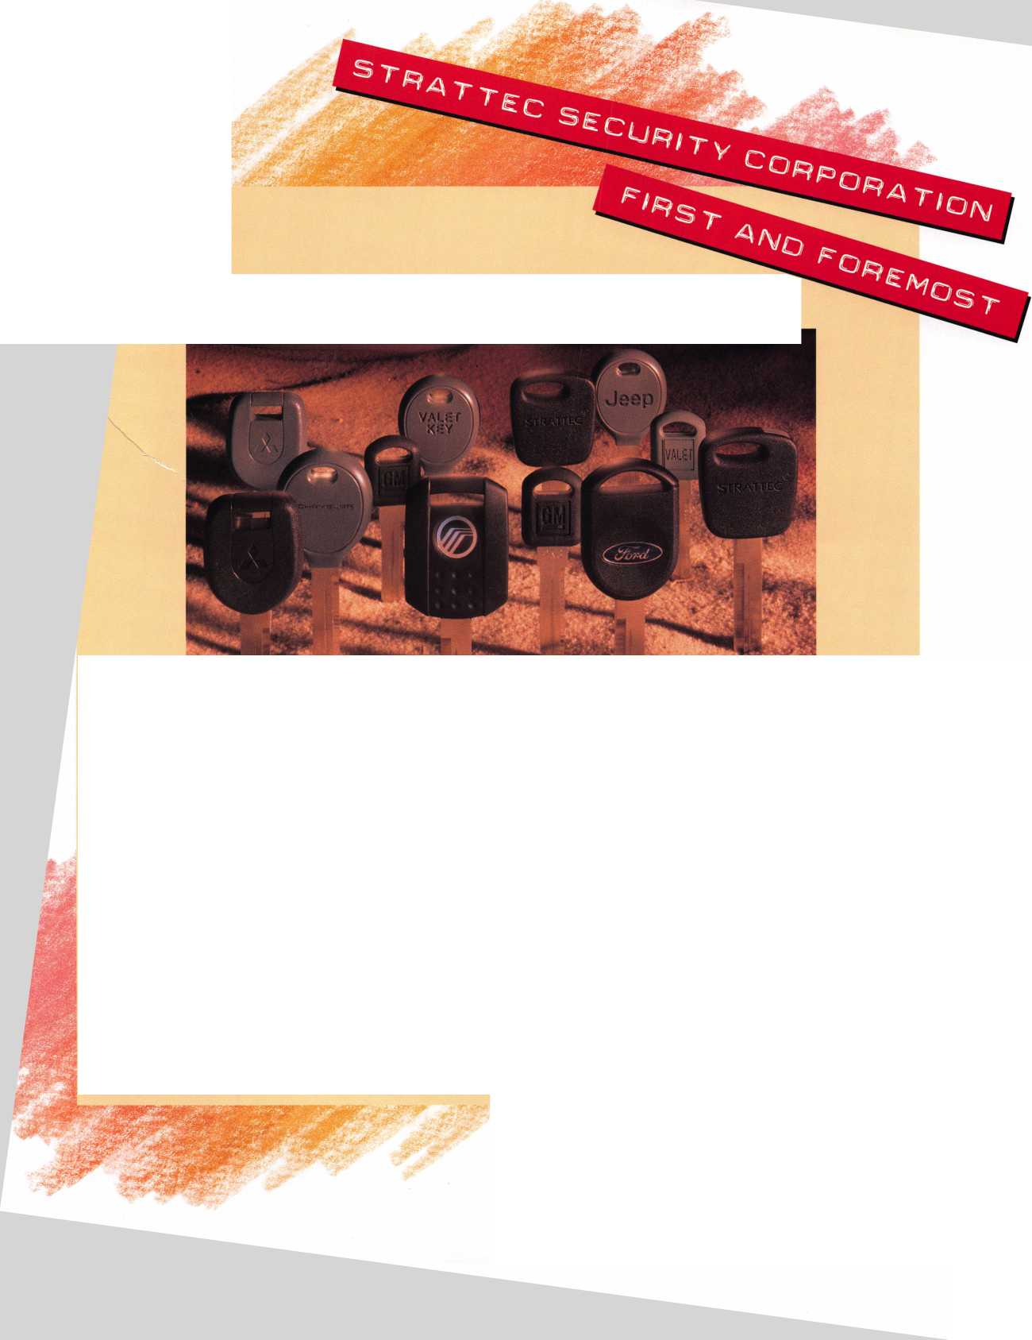

' Jump ahead of the competition at warp speed and see your profits soar.

**Hickok’s New Generation STAR transports you with the factory tool for programming keys to  
Ford-Lincoln-Mercury and Mazda vehicles with passive anti theft systems (PATS).**

**Program vehicle keys through Model Year 2001 with Hickok’s NGS Model 800-8LA-$1995 ^ Update your existing software-the 2001 Complete New Model Ford Software Update Model 80LA-$895 J**

**HICKOK**

**800/342-5080**

**INCORPORATED**

**[www.hickok-inc.coi](http://www.hickok-inc.coi)**

